DEVELOPMENT OF A PERFORMANCE REVIEW AND SKILL DEVELOPMENT SYSTEM WITH AN AI-ASSISTED PERFORMANCE AND LEARNING ANALYTIC DASHBOARD

A Capstone
Presented to the Faculty of
The College of Computer Studies
Bestlink College of the Philippines

In Partial Fulfilment
of the Requirements for the Degree
Bachelor of Science in Information Technology

YUAN A. AMBOY
HEXA B. AN̈ONUEVO
EYMARD C. BUYSER
CELSI A. GARCIA
JANNAH MAE NUEVA

September 2026

APPROVAL SHEET

This capstone entitled DEVELOPMENT OF A PERFORMANCE REVIEW AND SKILL DEVELOPMENT SYSTEM WITH AN AI-ASSISTED PERFORMANCE AND LEARNING ANALYTIC DASHBOARD prepared and submitted by: Yuan A. Amboy, Hexa B. Anonuevo, Eymard C. Buyser, Celsi A. Garcia, and Jannah Mae Nueva in partial fulfilment of the requirements for the degree of Bachelor of Science in Information Technology, has been examined and is recommended for acceptance and approval Pre-Oral Defense.

MR. VINCENT CARLOS T. GARADOS
Adviser
CAPSTONE REVIEW PANEL
Approved by the Committee on Pre-Oral Defense on _____________
with a grade of ______

Member Member
Chairperson

Accepted and approved in partial fulfillment of the requirements for the degree of Bachelor of Science in Information Technology.

ROMMEL J. CONSTANTINO, DIT
Dean, College of Computing Studies

Date of Pre-Oral Defense:

ACKNOWLEDGEMENT
The researchers profoundly express sincerest thanks and appreciation to the invaluable assistance and continued support of several individuals who contributed and extended their valuable assistance in preparation and successful completion of this study:

Dr. Maria M. Vicente, President of Bestlink College of the Philippines, we extend sincerest gratitude for the assistance and supervision given to all the school students in the Bestlink College of the Philippines.

Dr. Charlie I. Carino, Executive Vice President of Bestlink College of the Philippines, we extend our gratitude for inspiring and motivating us to finish this research. For patience, guidance, and support are highly valued and appreciated.

[Dean’s Name], Dean of College of Computer Studies of Bestlink College of the Philippines, for providing guideline documentation regarding the project.

Mr. Rommel J. Constantino, Department Head of IT Department of Bestlink College of the Philippines, for the constant supervision as well as providing necessary information regarding the project and also for his support in completing this project.

Mr. Vincent Carlo T. Garados, Our Research Adviser, for giving us suggestions and ideas to improve our research and guiding us in completing this project.

Ms. Kris C. Villaflores, Our Research Coordinator, for assisting us and wholehearted support in this project.

[Name Here], Head of CRAD, for providing us with the necessary resources, facilities, and opportunities to conduct our research. We are thankful for the conducive academic environment that fosters exploration and innovation, allowing us to grow both academically and personally.

Above all, we acknowledge and give thanks to our God Almighty for His divine guidance, wisdom, and inspiration throughout this research endeavor. We recognize His blessings and guidance, which have strengthened our determination and fueled our curiosity in the pursuit of knowledge.
DEDICATION
This research is dedicated to our families and loved ones , who have stood by us through the ups and downs of this whole research endeavor, we dedicate our achievements, honestly. Your unwavering belief in us has fueled our determination to push the boundaries of discovery.

We express our deepest gratitude to our professors, who have guided us along this journey, providing wisdom, encouragement, and support. Your guidance shaped us into the researchers we are today.

Finally, to the future generations of researchers and scholars, we dedicate our discoveries. May they serve as beacons of inspiration, igniting new ideas and driving progress, for the betterment of society.

We recognize His blessings and guidance, which have strengthened our determination and fueled our curiosity in the pursuit of knowledge.

ABSTRACT

Title: DEVELOPMENT OF A PERFORMANCE REVIEW AND SKILL DEVELOPMENT SYSTEM WITH AN AI-ASSISTED PERFORMANCE AND LEARNING ANALYTICS DASHBOARD

Author: Yuan A. Amboy
Hexa B.An̈onuevo
Eymard C. Buyser
Celsi A. Garcia
Jannah Mae Nueva

Degree: Bachelor of Science and Information Technology

Majors: Information Management, Network Administration, Information Security

Date of completion: 2026
TABLE OF CONTENTS
Page
TITLE PAGE i
APPROVAL SHEET ii
ACKNOWLEDGMENT iii
DEDICATION v
ABSTRACT vi
TABLE OF CONTENTS viii
LIST OF TABLES xiii
LIST OF FIGURES xiv
LIST OF APPENDICES xv
CHAPTER
1 INTRODUCTION
1.1. Project Background and Motivation 1
1.2. Problem Statement 3
1.3. Project Vision and Scope 7
1.4. Objectives and Goals 8
1.5. Significance and Relevance 10
1.6. Definition of Terms 12
1.7 Structure of the Document 14

CHAPTER
2 RELATED LITERATURE, STUDIES, AND TECHNICAL BACKGROUND
2.1 Review of Related Literature 16
2.2 Analysis of Related Studies
and Existing Systems 18
2.3 Agile Scrum Methodology
2.4 Emerging Technologies, Intelligent
Systems, and Standards in Modern
Information Systems 20
2.4.1 Microservices Architecture 22
2.4.2 Artificial Intelligence (AI) 24
2.4.3 Internet of Things (IoT) 26
2.4.4 Data Analytics and Business
Intelligence 28
2.4.5 Polyglot Persistence 30
2.4.6 Cybersecurity 32
2.4.7 Data Privacy 34
2.4.8 Software Quality Standards 36
2.4.9 Cloud Computing 38
2.4.10 Edge Computing 40
2.5 DevOps Culture and CI/CD Practices 42
2.6 Enterprise Architecture & System Integration 44
2.7 Conceptual Framework 46
2.8 Theoretical Paradigm 48
CHAPTER
3 METHODOLOGY AND PROJECT MANAGEMENT
3.1 The Adapted Agile Scrum Framework 52
3.1.1 Team Roles and Responsibilities
3.1.2 Scrum Events
3.1.3 Scrum Artifacts
3.1.4 Toolstack
3.2 Architectural Design Decisions 56
3.2.1 Why Microservices? Justify the choice over Monolithic architecture.
3.2.2 Core Architectural Patterns Used
3.3 Development, Operations, and Quality Assurance (QA) Methodology 60
3.3.1 DevOps Toolchain
3.3.2 CI/CD Pipeline Design
3.3.3 Testing Strategy
3.4 Innovation Framework 62

REFERENCES 120
APPENDICES 124
CURRICULUM VITAE 140

LIST OF TABLES
Table Page
- Roles and Responsibilities 27
- Sprint Cycle 33
- Product Backlog (User Stories) 37
- Product Backlog for EIS Information Security 47
- Product Backlog for EIS Standards 49
- Product Backlog for EIS Integration 51
- Product Backlog for Analytics 56
- Product Backlog for EIS Analytics 58
- Sprint Backlog (User Stories) 60
- Scrum Board 73

LIST OF FIGURES
Figure Page
- Agile Scrum Framework 26
- Burndown Chart 76
- Microservices Diagram 79
- Communication Pattern 80
- Data Flow Diagram 81
- CI/CD Pipeline 85
- Infrastructure as a Code (IaC) 85
- Monitoring and Alerting 86
- Integration Diagram 88
- API Gateway 88
- Data Flow Diagram 89
- Use Case Diagram 92
- Sequence Diagram 93
- Flowchart 93

LIST OF APPENDICES
Appendix A DETAILED TECHNICAL DOCUMENTATION
A.1 System Architecture
A.2 Information Systems Integration
A.3 Application Design and Development
A.4 Database Schema and Data Management
A.5 Network Configuration
A.6 Deployment and Infrastructure
A.7 Security Measures
A.8 Testing and Quality Assurance
A.9 System Monitoring and Maintenance
A.10 APIs and Integration Points
A.11 User Documentation
A.12 Known Issues and Troubleshooting
A.13 Version Control and Source Code Repository
A.14 DevOps and CI/CD
A.15 Licensing and Open Source Libraries
A.16 Performance Metrics and Monitoring
Appendix B: Project Management Artifacts
B.1 Project Charter / Proposal
B.2 Sprint Backlogs and Burndown Charts
B.3 Meeting Minutes (Key decisions should be documented)
B.4 Gantt Chart or Project Timeline
Appendix C: Research and Requirements Artefacts
C.1 Approved Adviser Acceptance Form
C.2 Company Endorsement / Memorandum of Agreement
C.3 Survey Questionnaires and Raw Data
C.4 Interview Transcripts and Guides (Anonymized)
C.5 UAT Forms and Signed Off Sheets
C.6 Certificate of Originality
Appendix D: Certificate of Technical Adviser and Grammarian
Appendix F: Defense and Validation
F.1 Panel Evaluation Sheets (Signed)
F.2 Photos from Defense and Pilot Testing
F.3 Certificates of Copyright / Patent Application (If any)
Appendix G: Access Links (All valid for 3 years)
G.1 Live System URL
G.2 Source Code Repository (e.g., GitHub)
G.3 Comprehensive Online Documentation (e.g., ReadTheDocs, GitBook)
G.4 System Demo Video (YouTube/Vimeo)
G.5 CI/CD Pipeline Dashboard (if publicly accessible)
Appendix H: Technical Adviser Curriculum Vitae
Appendix I: Research Adviser Curriculum Vitae
Appendix J: Researcher’s Curriculum Vitae

CHAPTER 1
INTRODUCTION
1.1. Project Background and Motivation
Artificial intelligence (AI), has gained prominence as a crucial technology within human resource management by enabling companies to execute standard administrative jobs, scrutinize workforce SCs and make wiser decisions based on this data. Nevertheless, human beings are still considered to play an indispensable role in processing and understanding the information provided by AI in the process of making various decisions related to human resources. From the study conducted by Gélinas et al. (2022), we can conclude that AI can be utilized in many HR fields such as strategic human resource planning, recruitment, and deployment, training, and development, performance management, compensation management and employee relations. This indicates the considerable possibility for AI to improve HR processes and use data for better workforce management. At the same time, the implementation of AI in the sphere of human resource management brings new issues related to the law and ethics.

Performance Management (PM) is one of the most crucial engagement when it comes to enhancing the employees output, promoting creativities, and increasing the organizational efficiency. This operates as one of their collaborative endeavors between the manager and the employees to be able to set clear objectives, assess the outcomes, and be connected to the rewards for real performance. Contemporary PM depends significantly on a Human Resource Information System (HRIS)—a tech integration that diminishes its effectiveness if HR teams continue with manual, paper-based tracking. Developing from extensive management information systems (MIS), HRIS utilizes technology to enhance resources and address organizational issues. Utilizing a strong HRIS enables departments to enhance their daily productivity while aligning their workforce objectives with the overarching corporate strategy (Raja et al., 2024).

The Performance Review and Skill Development System proposed by us comes with an AI-Assisted Performance and Learning Analytics Dashboard. The present system applies an AI-assisted analytical algorithm. Such an approach enables organizations to turn the collected data about the workers into useful organizational insights. The proposed concept allows collecting information from numerous modules (Performance Management, Competency Management, Learning Management, Training Management, Succession Planning, and Social Recognition) and then applying methods of data aggregation and statistical analysis. The algorithm can produce useful insights such as average performance rates, competency score, learning completion rate, succession readiness, workflow status, and department performance (Kim, 2024). Then, the algorithm utilizes rule-based analysis combined with reasoning based on the large language model (LLM) in order to interpret the numbers, determine the strengths of the organization, identify the weaknesses, and generate contextual recommendations meant for HR managers (Dadaboyev et al., 2025). Each of the modules of the system provides its unique AI-generated insights that are based on the relevant statistics thus improving the accuracy of the reports and providing reliable information instead of generalized reporting (Tang et al., 2025). The above presented approach agrees with the recent research evidence which indicates that Artificial Intelligence in Human Resource Management should be transparent, interpretable, and data-fueled, thus aiding the management decision-making and keeping accountability and human control (Kim, 2024; Dadaboyev et al., 2025).

1.2. Problem Statement
As stated by Radhika, B. (2018), the creation of a transparency performance evaluation is essential for this to maintain the credibility of the evaluation processes. The employees that tended to trust in evaluation results showed greater credence in the criteria and assessment methods held by the company who clearly defined their works. This degree of transparency is upheld via ongoing feedback mechanisms instead of separate yearly evaluations. Consistent performance evaluations offer an organized framework for addressing employee growth and immediate opportunities for enhancement. As a result, this continuous process maintains the relevance of evaluation data and guarantees that talent development relies on present workplace performance.

Additionally, conventional human resource tasks depended greatly on manual documentation and personal intuition to oversee recruitment, regulatory adherence, and payroll processing. Although effective in less complex operational settings, this non-empirical method frequently led to inconsistent outcomes in retention and employee engagement efforts. In the current scenario, Human resources analytics resolve HR challenges via data-based workforce management practices. Instead of relying on assumptions to understand turnover or predict the success of candidates, organizations can now collect data and identify behavior patterns. This change makes HR evolving from a reactive administrative function into a proactive strategic asset that may align human resource activities with high-level goals of the company (Kessavane, 2025).

1.3. Project Vision and Scope
The aim of the research is to create a Performance Review and Skill Development System with an AI-Assisted Performance and Learning Analytics Dashboard for firms in the hotel and restaurant segment. The purpose of the system is to consolidate the evaluation of employee performance, the development of various competencies, the management of learning, training administration, succession planning, social recognition, and the management of certificates in a single web-based program.

The system will perform the most critical functions of Human Resource development processes through automation, including performance evaluation, competency assessment, learning monitoring, training administration, certificate production, and AI help in workforce analysis. The role of the AI component will be to provide support in making decisions based on the analysis of information available in the organization and will not replace human judgment in its entirety.

The system is developed with the use of Role-Based Access Control (RBAC), which will limit the access to the information and functions only available to a certain role:

HR Administrator
The HR Administrator possesses complete administrative authority over the system and is in charge of handling all Performance and Development modules. More precisely, the HR Administrator has the ability to:
- Oversee the performance assessment cycles and KPI models of employees.
- Handle competency profiles as well as plans for employee development.
- Maintain the learning history and training plan database.
- Confirm the enrolment of employees in the programs and their attendance.
- Maintain the data on succession planning and assessment of readiness.
- Oversee social recognition of employees and their prizes.
- Create, hand, withdraw and recreate the certificates for employees.
- Utilize data on AI-assisted performance and learning analytics of the whole organization.
- Monitor all workflow processes.
- Manage notifications and records of the development of employees.

Department Head/Supervisor
Department Head is in charge of assessing and supervising employees in their respective department. They have the power to:
- Carry out employee performance assessments.
- Evaluate employees' self-assessments and lodge a report.
- Supervise competence development in the department.
- Monitor a personnel’s progress in terms of learning.
- Advise on training, advancement of an employee, and awarding recognition.
- Double-check whether the individual attended training or not.
- Utilize AI-generated info about the department.
- Take part in operations that are related to his/her job.

Operation Manager
The role of the Operations Manager is to supervise and analyze the operational effectiveness of the people in charge of a certain task without performing any human resources administrative duties. The Operations Manager has the authority to:
- Track the performance assessment and KPI figures.
- Check on the capabilities of the employees and their weaknesses in terms of learning.
- Track the process of education and application of training.
- Confirm or inspect the processes of training if applicable.
- Examine the level of successors and offer appropriate staff.
- Examine the process of employees’ admitting.
- View dashboards from operations and departments which contain AI technologies.
- Know how well the task has been processed and anything important notification concerning the operations.
The Operations Manager does not have the ability to work with employees’ accounts and does not have the power to set up or modify anything in the system.

Senior Manager
A senior manager holds the position of senior executive user with organization-wide access for strategic decisions. Apart from this, senior manager can:
- See the whole organization's workforce's reports on performance.
- See the summaries of each competency, learning, training, and succession.
- Access executive AI-enabled workforce analytics reports.
- Read the various strategic reports and organizational dashboards.
- View the workflow, but not change any operational records.

Employee
Employees engage only with their information about their individual growth. Employees can:
- Carry out assessments of their own performance and results.
- Access reports on how they have performed.
- Check their plans for competence development.
- Keep track of their education and training.
- Join in the training that they have to do.
- See all the awards they have received.
- Get certificates given to them.
- Have reports generated by artificial intelligence about their progress and education.
- Get development hints based on their own records.

AI-Assisted Analytic Scope
AI functions follow specific function and access limitations, which have been integrated into P&DSS via Role-Based Access Control (RBAC) so that the AI analysis can utilize only the information that the specific user is entitled to access. The AI tool has been built into various levels of P&DSS infrastructure architecture. At the front end level, the AI analysis and reports are presented via different analytic and module interface. On the back end side, the system retrieves necessary employee and organization data, compiles the prompt to be sent to AI, and interacts with external AI service. Finally, at the storage level, the reports and snapshots of the employee and organization metrics are saved in the PostgreSQL database.

The activation of the AI tool is possible through the interface while authorized users can start the tool without any external aid. Moreover, it is important that the completion of necessary system processes may also become grounds for the formation of new snapshots for the AI report. Thus, it can be concluded that AI is incorporated into the analytical support system of P&DSS rather than being an independent component of the system.

The main functions performed by the AI include the following:
- Scope of AI Activities – The AI system produces workforce reports at an organizational level that are useful for HR managers and specialists. With the help of such reports, the state of the workforce, actions of each department, gaps in competency, the preparedness of specialists to take on higher positions, and the priorities of the organization can be assessed.
- Performance Management – The AI analyzes performance-related metrics of personnel including rates of performance, status of performance review completion, trends in performance, and identified coaching requirements.
- Competency Management – The AI analyzes competency-related data in order to identify proficiency gaps, development needs, and areas that need further development of capabilities.
- Learning Management – The AI analyzes the educational achievements of employees, such as the amount of training completed and the level of involvement in studies.
- Training Management – The AI analyzes the data related to training such as attendance and training progress
- Succession Planning – Using the data that has been fed into the system, the AI offers information about the succession of the leadership in the organization.
- Social Recognition – The AI processes the available data regarding recognition, identifies patterns and gives ideas about both employee recognition and employee engagement as a whole.
- Personal development of employees - The personalized recommendations given by the AI depend solely on the data about the employee generated within the organization and amicably distributed to the actual employee with no reference to any organization-related information that might be confidential.
Limitation
The research focuses solely on the administration of employee performance evaluations and skill enhancement. It excludes payroll processing, recruitment and candidate tracking, attendance tracking, leave administration, financial oversight, or automated HR decision-making. The AI element functions exclusively as a decision-support tool by analyzing system-generated data and offering suggestions. Conclusive decisions related to employee assessment, advancement, training, and career progression are ultimately at the discretion of designated HR staff and management.
- Dependence on Available Data - The AI system is dependent on the employee and organizational data available in the system. If there are no records or enough relevant metrics, the system will not be able to provide reliable data-driven insights for the area. The system will simply show that there are insufficient records available.
- Dependence on External AI Services - The main AI engine depends on the OpenRouter API, so it requires internet access and a properly configured API key. Any interruption of the network or unavailability of the service can affect the creation of the AI-based reports.
- Limitations of Fallback Output - In the absence of the external AI service, the system uses a deterministic template-based approach. Nevertheless, this keeps the system operational, but the output will not have as much linguistic diversity and flexibility compared to the output produced by the LLM in normal circumstances.
- Advisory Function Only – The model is used solely as a decision-support and analytical instrument. Its capabilities do not include autonomous administrative actions including employee record edits, compensation modifications, training allocation and HR process steps execution. The final administrative decisions continue to be made by authorized HR representatives.
- Limited Historical Context – Each generation of the AI is based on the data given during that very request. The model does not remember earlier conversations with users or learn historical data about employees on its own unless relevant historical information is retrieved separately and included in the prompt given.
- Output Length Limitations – The output generated by the software is expected to remain short to keep it comprehensible and usable within the system. Hence, the AI may not provide an extended multi-page overview or detailed text.
- Structured Interaction – Presently, the AI relies on predefined templates and prompts for report generation. It is not like a full-fledged HR assistant that gathers unstructured questions and discusses organizational data over an extended period.

1.4. Objectives and Goals
1.4.1. General Objective
The main goal and objectives of this research are to create a Performance Review and Skill Development System with an AI-Assisted Performance and Learning Analytics Dashboard that simplifies employee performance assessments, fosters ongoing learning and skill development, and equips HR professionals with AI-Assisted performance and learning analytics to improve employee growth and facilitate data-informed decision-making within hotel and restaurant businesses.

1.4.2. Specific Objectives
The study specifically aims to:
Specific Objectives | Description
Develop a Performance Review Module | Developing and implementing in which it can help the HR's personnel and managers carrying out uniform employee performance assessments based on the already defined Key PerformDevelop and implement a module which helps HR personnel and managers carrying out uniform employee performance assessments based on the already defined Key Performance Indicators (KPIs), evaluation benchmarks, and feedback systems.
Develop a Skill Development Module | Design a module to monitor the skills of employees and their educational activities, training programs, certifications, and plans for personal development in order to monitor the promotion of employees.
Centralize Employee Performance and Learning Records | Implement a unified database that collects information about the employees’ performance, competence assessment, training documents, and education to make it easier for users to access and process the information. advancements to enhance data accessibility, consistency, and precision.
Implement an AI-Assisted Performance and Learning Analytics Dashboard | Develop an analytical dashboard showing the information about employees’ performance and education by means of AI technology that will help to summarize the data on employees, define the skills’ gaps, analyze the performance trends, and provide suggestions about their development for HR managers.ance Indicators (KPIs), evaluation benchmarks, and feedback systems.
Monitor Learning Progress and Training Effectiveness | Prepare analytical reports and dashboards for HR managers which enable them to track advancements in personnel education concerning the performance of training, thus determining the gain in competencies.
Support Data-Driven HR Decision-Making | HR personnel and managers are supplied with information concerning performance, as well as recommendations powered by AI technology, to make impartial decisions about employee training, promotion, and development.
Evaluate the Developed System | Test the functionality, usability, efficiency, and safety of the system according to Software Quality Model ISO/IEC 25010 ensuring it meets all the requirements of the customer.
Table 1. Goals and Objectives

1.5. Significance and Relevance
1.5.1. Significance of the Study
The Performance Review and Skill Development System with an AI-Assisted Performance and Learning Analytics Dashboard is expected to provide significant benefits to hotel and restaurant organizations by improving the management of employee performance evaluation and professional development. By integrating performance reviews, learning management, and AI-assisted analytics into a centralized platform, the system aims to promote more transparent, objective, and data-driven human resource management practices.

Specifically, this study is expected to benefit the following:

A. Users
A.1 Human Resource Personnel
HR personnel will be able to use the platform to standardize performance evaluations, track employee development, identify knowledge and ability gaps, and organize the relevant paperwork. Moreover, the AI-Assisted analytical dashboard will provide various relevant information and recommendations to help HR professionals make data-backed decisions without performing a lot of manual analytical work.

A.2 Managers and Supervisors
Managers and supervisors will gain from accessing employee performance reports, learning advancements, and competency evaluations that enable equitable and uniform assessments. The system will additionally aid in identifying employee strengths, areas for growth, and possible improvement opportunities.

A.3 Employees
The employees will benefit from the transparent evaluation system that can provide immediate feedback about their performances and their skill development that they've shown. The platform will enable the staff to monitor their own educational progress, the completed training, the skill improvements, and the overall performances, this also fosters the continuation of their professional growth.
A.4 Hotel and Restaurant Organizations
The proposed system will assist organizations in enhancing employee performance assessments and skill advancement procedures via a centralized and automated platform. It will offer management precise performance and learning analytics to aid in workforce planning, employee growth, and operational enhancement.

A.5 Academic Institution
The research should be useful for academic institutions providing courses in Information Technology, Computer Science, Human Resources Management, Hospitality Management, and comparable fields to teach Human Resource Information Systems (HRIS), performance management methods, learning management systems, workforce analytics, and AI applications in organizational management. Moreover, the research is expected to become an important source for further investigations related to decision support by AI in the area of human resource management.

B. Technical
B.1 Information Technology Personnel
The research can enable information technology employees to benefit from an architecture that includes the integration of contemporary web solutions, database management, RESTful APIs, authentication mechanisms, and artificial intelligence-supported analytics within the scope of HRIS. It may be used as an instruction for the implementation, support, and upgrade of similar HR systems in different organizations.

B.2 Software Developers and System Designers
The findings may give application software developers and system designers valuable information concerning the design and implementation of the newly introduced Performance Evaluation and Skill Development System that features artificial intelligence-enabled analytics dashboards, workforce data visualization, and modular HRIS architecture. The suggested system may be used as a model for the creation of scalable and maintainable HR applications with a focus on the interests and needs of customer users.

C. Researchers and Future Developers
This research could act as a resource for future researchers and system developers focused on Human Resource Information Systems (HRIS), performance management, learning management, workforce analytics, and AI-driven decision support. The results and system design could aid in enhancing and inspiring future advancements in HR technology.

1.5.2. Relevance of the Study
The proposed research is particularly relevant to the growing need for digital transformation in Human Resource Management, especially in the hotel and restaurant sector where staff performance and service excellence are crucial for organizational success. Numerous organizations persist in depending on manual or disjointed performance evaluation and employee development methods, leading to inconsistent evaluations, postponed feedback, and restricted use of workforce data.

This study focuses on the solution of issues mentioned above through a Performance Review and Skill Development System which has a professional AI-Assisted Performance and Learning Analytics Dashboard as its core component, thus providing the enterprise with an all-inclusive solution for performance evaluation, personal development and further skill improvement, while transforming available workforce information into useful data. Thanks to this integrated AI-based solution, HR specialists can look at the performance and learning information more objectively and make data-based decisions without losing the human perspective.

Moreover, the study is in line with current trends in the fields of Human Resource Information Systems (HRIS), workforce analytics and AI, demonstrating how modern technologies can contribute to employee development and organizational effectiveness. As companies adopt digital HR solutions more widely, the proposed system represents an appropriate and flexible means of improving both performance management and continuous learning in hospitality.

1.6. Definition of Terms
- ‎AI-assisted: ‎Is a software tool powered by artificial intelligence that responds to user prompts to answer questions, draft text, complete digital tasks, and helps them in decision making. Nowadays AI is being increasingly used to help human experts make decisions in high-stakes scenarios that shows high potential in improving human decision-making by providing decision recommendations and problem-relevant information to assist human decision-makers. The use of AI-assisted decision making feels different when the individual strengths of the human and the AI come together to optimize the joint decision outcome. It then allows us IT students to appropriately apply our knowledge using AI tools who help us improve our decision outcomes in cases where our model is likely to perform poorly.

- ‎Artificial Intelligence (AI): is computer technology that lets machines think, learn, and solve problems like humans. Artificial Intelligence consists of data, algorithms, and computer/machine powers that have the ability of computers and machines to do tasks that usually need human thinking, such as learning, solving problems, and making choices. This enables the machines to virtually perform tasks that typically require human cognition, such as reasoning, learning, and problem-solving. It is also primarily used to analyze vast datasets, recognize patterns, make predictions, do some task automation, increase speed and efficiency of work, and improve data-driven decision-making that the researchers use as a tool to be more innovative and more practical for ease of developing a system for the better future.

- ‎Automated Platforms: is a digital tool that can execute repetitive tasks and connect different software apps with a little human help, it is also a tool that links separate software applications, data sources, and hardware so they can work together automatically. This is a setup of computers, software, sensors, and machinery that does tasks on its own. This automated platform comprehends the suite of tools and technologies that are designed to be streamlined into the system and enhance the business processes through an all out automation.

- ‎Docker: is a free and open-source platform for containerization which can be defined as a tool that helps programmers encapsulate their applications along with all associated dependencies, libraries, and configuration settings into one neat, easy-to-carry unit, also known as container. It helps to ensure that the application will perform equally well in different computing environments and/or it can also be used to develop and launch an application in an isolated space of a container that is based on open-source technology. It virtualizes the operating system layer rather than the physical hardware, allowing software to run reliably regardless of the machine it is on.

- ‎Human Resource Information System (HRIS): ‎is a software platform that centralizes employee data and automates core HR processes like payroll, time tracking, and benefits the administration. It is also used by companies to centralize their employees' data and automate the core human resource tasks. The software solution became essential for the company to act as their digital filing cabinet and HR command center, instead of using some of the scattered paperwork and the use of endless spreadsheets, the company uses an HRIS for them to securely store all of them employee data and to also automate the daily HR task.

- ‎Learning Analytic Dashboard: A visual screen that displays the information, progress, and performance figures. The screen simplifies complex numerical information turning them into charts and graphs. The dashboard enables the users to succeed in achieving their goals through the monitoring of important parameters. The device gathers, processes, and presents different figures and numerical data in one place. It also transforms complex numbers into graphs, tables or charts providing the opportunity to recognize trends and decide quickly. One of its functions is to gather and analyse the clients’ information that is necessary to optimize learning. By providing decision making on the basis of evidence rather than guesswork, this tool helps teachers to execute individual technique, detect the low achievers in the early stages of the learning process. And the main purpose of this dashboard is to track key performance indicators, monitor important metrics, and provide a single view of data. This will help the users to see the vital information quickly, can spot the trends, and will make smart choices fast.

- Microservice: is an efficient architecture style of organizing a program into smaller self-sufficient services which communicate via quick APIs. Likewise, it is an approach of developing software where an application is divided into different independent sections. Instead of using one big software program (monolith), this architecture consists of the adaptation of the program to certain tasks by means of communication among sections.

- ‎Modular Monolithic Architecture: refers to software structure wherein a program is produced in just one deployment unit but has its code separated into distinct loosely coupled sections. This structure merges ease of deployment characteristic of traditional unitary structures with the clean and coherent evenness of business principles linked to microservices. Output characteristics of this arrangement include definite deployment unit, clear cut module borders, and inter-module communication based on publicly available APIs. Thus, this construction combines the simplicity typical of monolithic arrangements with principles governing separation of functions and processes typical of microservices.

- ‎Performance Review: Performance Review is also known as Performance Appraisal or Employee Evaluation. This procedure is used to analyze the employee's work including tracking goals and measuring results like the employee's work performance. It is also the basis on when to set a meeting or did they meet any agreed objectives that demonstrates the right behaviours in their work—following an agreed development plan if there is one, for example by doing any ongoing training.

- ‎Product Backlog: is a single, organized list of all the work needed to build and improve a system. It features user stories, bug fixes, and technical tasks. It acts as the central master plan for the development team. It serves as the living list of features, bug fixes, and tasks that serves as the single source of work for a team. A product owner manages a product backlog that is used in Agile and Scrum frameworks to steer product development. A product backlog is a dynamic prioritized master list of all work to be done to achieve the final product, be it to develop, maintain or improve a product. As a single source of truth for the team, it helps unify what are the features and improvements which will (possibly) provide the greatest value and which is the necessary work for developing, maintaining, or improving a product. The entry of the backlog may include user stories, bug fixes, and new features.

- ‎Skill Development: Links the employees growth that directly executes its job, it continuously focuses on feedback, skill gap analysis, and targeted coaching rather than yearly reviews. The process of acquiring, improving, and expanding their personal and professional abilities through learning, training, and practice helps them do their jobs better, and adapt to changes that enhances their personal growth, boosting workplace productivity, and driving economic progress that can help them reach their full goals. The goal of the skill development is to unlock the employees' adaptability for changing environments, securing better career opportunities, and to solve some of the complex problems efficiently.

- Transparent Assessment: Systems of assessment are implemented in a way that is transparent and accessible to all parties involved. The process of assessment is explained in detail so that every party knows the rationale and decision-making process behind the assessment and can make informed choices. Evaluation transparency is realized through procurement, financial assessment, and governance. Organizations organize proper processes at every stage of the implementation such as data collection and approval making sure that each of these processes is documented and can be followed later.

- ‎Transparent Evaluation: This refers to the clarity, openness, and availability of criteria, methods, and processes used in assessing the vendors, projects, or financial operations. This results in the creation of a situation in which all participants know how the evaluations are being done, which factors impact the results, and how decisions are made or justified in general, thereby making the system more accountable. In real-life applications evaluation transparency is incorporated into procurement, financial evaluations, and governance systems. Organizations create workflows. Every step taken, including the one of data gathering or approval, has documentation and tracking.

1.7. Structure of the Document
This document is divided into multiple sections, with each one concentrating on a particular element of the capstone project. The following sections will explore the technical and architectural aspects of the project, the development process, testing and quality assurance, along with the outcomes, assessment, and insights gained. At the conclusion of this document, readers will achieve an in-depth insight into our subsystem and its influence on the operational efficiency and effectiveness of HR.

CHAPTER 2
RELATED LITERATURE, STUDIES, AND TECHNICAL BACKGROUND
2.1. Review of Related Literature
Foreign Literature
Human Resource Information System (HRIS)
For the past few years the use of Human Resource Information System (HRIS) has been greatly seen as the most advanced and relevant in a systematic way for managing different businesses across the world, it has taken a prominent role in those specific processes that became effective and well-crafted as a human resource management in a now digitally transformed strategy based on the studies focusing on the all encompassing framework for the implementation of human resource management digital transformation within enterprises that contains various domains and sectors by Poulose, S. et al. (2025). According to Nikica R. et al. (2025), their findings shows that the digital transformation enhances the value of creation and not by substituting but by reconfiguring human services, with technology alleviating routine tasks and enabling employees to focus on relational and creative aspects of hospitality in alignment of technological innovations with supportive HR practices, ensuring that both of the guest satisfaction and the employees motivation can up hold the innovation practices. In today's knowledge-based economy, business success relies heavily on the performance of its human resources, which are essential in a rapidly changing global environment. Businesses continually strive to stay ahead of the curve in the ever-evolving technology landscape to thrive in the market, that's why implementing Human Resource Information System (HRIS) has proven to be essential because it enhances business performance in the tourism and hospitality industry by Hussain et al. (2025).

Performance Management System
Modern performance management systems and methods of performance evaluation have evolved from traditional assessment methods that merely point to employee weaknesses to more modern approaches which facilitate the employee's development and the company's advancement. As shown by Vuong and Nguyen (2022) in their literature review, an effective performance management system has to do also with the clarity of goal-setting, responsiveness to workforce changes, the continuous process of 360-degree feedback, and self-evaluation opportunities. Instead of being restricted only to the occasional administrative evaluations, modern performance evaluation serves as an ongoing action that improves employee performance, demonstrates the areas of improvement, and facilitates organizational growth.

Modern employee performance monitoring systems also consider the main factors impacting productivity like organizational support, working environment, and systematic performance monitoring. As per Sakai (2026), monitoring systems are more effective when they are compatible with the operations of the company and are accompanied with precise key performance indicators, also known as KPIs. Moreover, modern performance management acknowledges the significance of employee engagement, organizational commitment, and both physical and psychological wellness. According to the findings by Abdelwahed and Doghan (2023), those who are engaged and committed are less likely to be absent at work and more likely to have better performance quality.

Performance management is crucial in hospitality and restaurant businesses, influencing the quality of service given by the staff and, hence, customers' satisfaction. According to Asgeirsson et al. (2024), the evaluation of employees' performance comprises service quality, productivity of staff, and reputation of a brand. As customer satisfaction greatly depends on the customer's perception regarding the quality of service received, contemporary hospitality performance management systems apply internal evaluations of employees and external customers' evaluations like electronic word-of-mouth (E-WOM). Thanks to the integrated approach applied by the companies, the quality of service is improved while customer loyalty is strengthened.

Skill Development and Learning Management
Improving employees' skills is defined as a continuous structured process of building technical, operational, behavioral, and digital skills for achieving effective results due to successful performances. According to Noe et al. (2021), effective skill development has a direct impact on operational efficiency, employee retention rates, and organizational capacity of adaptation in case of changes, especially for the sectors with changing conditions, such as hospitality. In the process of working in hotels and restaurants, it is essential to focus on particular skills as they will help to improve the quality of services and satisfaction of guests.

Modern methodologies have created combinations of training, micro-learning, practical training on-the-job, as well as addressing learning needs through feedback processes. Employee learning management system can be defined as a system that provides a digital solution for the seamless process of training administration, training implementation and progress monitoring and reporting on compliance. It unifies the process of training at different departments or locations, automates most of the processes, and makes the training available for employees at all times from any location via mobile and desktop devices.

Fitzgerald (2025), pointed out that digital systems make the scheduling process easier, the enrollment process automated, the certificates being tracked and audit-ready records created. Some of the common problems are scheduling conflicts, multilingual needs and the need to integrate training into the performance improvements. Solutions to those issues include using modules, making the content role-based and connecting the training with performance assessment and promotion criteria.

Competency Management
According to Bhamu et al. (2022), Human resources are regarded as one of the key assets for any kind of organization. From the organization's point of view employee development holds the key. The development of the employees mainly depends upon the competencies such as the knowledge, skills, and abilities that they have. To be successful, the organizations have to find and develop some competence among their employees to be more adaptive and competitive. Marneros, S. et al. (2022) states that, developing a set of core competencies should be of primary concern to any business operating in the hospitality industry. Because some of these specific competency items include essential capabilities for the hospitality industry such as: communicating effectively with clients and customers, identifying and solving problems, making decisions under pressure or in a crisis situations, and understanding the factors that influence the profitability of the hospitality enterprise.

Nevertheless, Rustam A. et al. (2024) argued that organizations encounter a unique scope of challenges regarding developing employee competences that conform to the pace of technology changes nowadays. Therefore, it is necessary for the HRD strategies to ensure the continuous learning of employees in terms of digital literacy and adaptation skills. Moreover, the ability to build a culture of collaboration and innovation is regarded as an important factor for maintaining the development of competences.

Artificial Intelligence in HR
Artificial Intelligence (AI) has become an integral component of Human Resource Management (HRM), enabling organizations to automate routine administrative tasks while improving workforce planning and decision-making. However, in order to drive decision-making and assist organizations with their workforce management, humans are still required. A scoping literature review of 85 studies in which AI was used throughout the Human Resource Life Cycle was conducted by Gélinas et al. (2022). The focus of the studies throughout the Human Resource Life Cycle was on strategic human resources planning, recruitment and deployment, training and development, performance management, compensation management, and employee relations. AI was found to be applicable across all major HR functions. Moreover, the use of AI in human resource management involves many legal and ethical implications.

However, Gélinas et al. (2022) have pointed out that AI must complement and not replace human resource professionals in their work since it can be very helpful in automating administrative tasks, facilitating the decision-making process, and using the employee information for performance management and the improvement of employee development. There are also ethical considerations, as well as the need for transparency and human oversight in AI-assisted decisions. The use of AI in HRM can assist the proposed Performance and Development Subsystem (P&DSS) by processing employee performance information, supporting employee evaluation, and enhancing employee development. However, human judgment must still be used in making the final HR decisions.

Local Literature
Performance Analytics
According to Paulino (2023), the term business analytics (BA) and business intelligence (BI) has only recently emerged in the Philippines. Because these are new concepts, it is necessary to evaluate the influence of these concepts on the organizational performance and performance metrics in the business industry. The goal of the research was to evaluate the influence of business analytics that generates business intelligence on the organizational performance through constructing a structural model. In addition, the influence of the organizational performance on the performance metrics has been identified. It has been shown that business analytics capabilities have a significant positive influence on the level of business intelligence, which has a positive impact on organizational performance. Nevertheless, it has also been shown that an organizational readiness to implement business analytics does not have a significant moderating impact on the relationship between business intelligence and organizational performance.

Learning Analytics
Learning and development are important in enhancing employee performance and organizational effectiveness. Quinicio (2025) emphasized that “A well-designed learning intervention will surely develop job performance of employees,” highlighting that employee performance is reflected through the quality and quantity of work produced, as well as workplace behavior. The study further stated that organizations should continually assess employees’ learning achievements to determine whether training objectives have been met and to provide appropriate learning and development opportunities. These findings support the proposed Performance and Development Subsystem (P&DSS), wherein employee learning progress and performance serve as the basis for HR administrators in monitoring employee career development, evaluating training effectiveness, and identifying employees’ training needs.

Data Visualization and Dashboard Analytics
The use of continued development in different fields has become unstoppable due to high demand of techno advancements, including the Restaurants who needed to visualize their context for the future to properly accommodate the customers and in order to meet their satisfactions. According to Romano et al. (2020) of the Mindanao Journal of Science and Technology, the restaurant industry has grown over the years along with the modernization of technology. Like any other area of this industry, the menu presentation also demands improvement. Possessing smartphones proved to be a necessity nowadays and regular restaurant customers with their phones bring an opportunity to materialize the concept. The idea of accessing the restaurant menu through smartphones is new to a restaurant in Oriental Mindoro, Philippines. Other than that they also stated that the development of this system can improve the customer's experience which would be beneficial to the restaurant. Proponents used incremental development as a software development method to come up with an efficient system. The developed system is user friendly and interactive. The customers will be able to see the actual picture of the dish with a short description, and other customers’ reviews. This research has been proven that the technology itself now becomes the soul of every field that wants to develop, improve, and to ride the flow of time.

AI Decision Support System
Artificial Intelligence (AI) is becoming increasingly adopted by organizations in the Philippines to enhance Human Resource Management (HRM), particularly in talent management and HR decision-making. In line with this development, a study recently conducted and participated in by 137 HR professionals based in Metro Manila was aimed at gauging and assessing the extent by which AI can enhance HR functions particularly in Talent Management or how organizations can manage their talent or their employees in terms of performance, enhance or improve the overall decision making in HR functions.

The study, conducted and authored by Parker and Jubac (2026) made use of the Technology–Organization–Environment (TOE) framework from previous studies, in order to determine and assess factors which could potentially affect an organization’s adoption of using technology for management of HR or in performing HR functions. The said study also employed the use of Partial Least Squares Structural Equation Modeling (PLS-SEM) in order to assess and determine or analyze the relationships and effects of variables within the study, particularly on how the said factors or variables affect an organization’s adoption of technology or in using AI for the organization’s HR functions as well as in assessing and determining the extent by which using AI in an organization’s HR functions can potentially affect or improve its Talent Management.

The findings of the study revealed that an organization’s technological readiness and organizational readiness greatly affects an organization’s adoption of technology for HR functions or using AI in an organization’s HR functions, wherein the said factors can enhance an organization’s Talent Management by providing decision support, enhancing processes and also in terms of consistency in the implementation of an organization’s HR functions or practices. Additionally, the findings also revealed that the use of technology or in using AI in an organization’s HR functions can serve as performance-enhancing tools to HR professionals rather than replacing them, wherein an organization’s and its HR functions readiness as well as leadership support is required for the effective use of technology or in using AI in an organization’s HR functions.

These findings are accordingly supported by the proposed Performance and Development Subsystem (P&DSS) within the study, wherein the said information system utilizes AI in analyzing employees’ performance data that would provide the HR administrator with decision support recommendations regarding the employees’ performance, while ensuring that HR administrators remain responsible for making the final performance evaluation and employee development decisions.

2.2. Analysis of Related Studies and Existing Systems
Google Sheets/Excel
Google Sheets and Microsoft Excel are two of the most popular data management and analytics tools used in organizations worldwide. Both of these spreadsheet programs are highly versatile, user-friendly and flexible, easily accessible, and widely known and used by users within organizations in many industries around the world. In their study, Rebman et al. (2023) among other things explained that the formulas, charts, and other spreadsheet features as well as the use of tools such as PivotTables, filtering, and data visualization in Google Sheets and in Microsoft Excel, enable organization users to process and use the data collected and stored in their spreadsheets and to create reports and carry out other types of data analysis that will support their work and decision making.

Two essential features for any type of analysis are formulas and charts. A very useful tool for analyzing data is a PivotTable that allows users to look at their data from different angles. Also, the ability to filter data and utilize data visualization are key when it comes to data analysis. Both Google Sheets and Microsoft Excel have these type of features, which allow organizations to complete required reporting and basic data analysis to support both operational and managerial decision making.

While both Google Sheets and Microsoft Excel have their points of difference and are favored by different users, the primary function of both applications is that of a simple spreadsheet. While they enable data to be input and then analyzed through formulas and sorted through various tools and features such as charts and PivotTables, and also enable data to be filtered and viewed through data visualization tools, both applications require data to be organized, analyzed and then interpreted by the user in order to gain meaningful results.

Rebman et al. (2023) stated that, although both Google Sheets and Microsoft Excel have been equipped with artificial intelligence (AI), no functions of either spreadsheet application are specifically intended for use in Human Resource Management, for the performance measurement of employees or for any decision support. In order to analyze data, both applications provide the functions that any spreadsheet can offer. By means of tables, charts and reports (PivotTables), filtered data can be presented to users in a user-friendly way.

BambooHR
BambooHR is an online-based Human Resource Information System and Human Resource Management System mainly created for smaller and mid-sized businesses. It collects employee information on one site, minimizing manual work and other HR functions and making them more efficient. Its main features include Centralized Database and Document Management: a safe place for storage and processing of employee records and documents; Hiring and Structured Onboarding: an applicant tracking system that supports hiring; Time, Attendance, and Leave Management: a self-service tool that allows employees to track their time and attendance; and Performance Management: a performance review system for self-reviews and peer appraisals. Besides, there are also included analytics and reporting: dashboards that display statistics related to employee performance and other important metrics like recruitment; and there’s Bamboo AI, the system where one may ask artificial intelligence to analyze some inputs and highlight important details like burnout risk analysis. Nevertheless, the system lacks customization capability thus making it only available for small and medium companies and not allowing large corporations to either own or use it properly.

SAP Success Factors
SAP Success Factors is an advanced, cloud-based suite for the Human Capital Management of enterprises, which integrates many functions such as talent management, learning management, performance management, and workforce planning and is used by large hotel chains and restaurant groups for the needs of their employee training across the whole organization (i.e. in numerous locations). It provides various training paths relevant to each job position, automation of certificates tracking for compliance with safety requirements, possibility of integrating with operational systems, allowances for usage of the system user interface in several languages, and via mobile devices. However, high implementation costs, complexity of the process of setting the system up, lack of specific educational materials for hotels, and limited offline capabilities for frontline staff are among the cons of this implementation. The tools of the basic AI version are able to provide suggestions regarding employee training and identify skill gaps, whereas advanced features are offered as add-ons or separate integrations with the system. The inbuilt employee learning analytics module helps organizations with preparing the reports regarding training completion and scores of the employees but lacks the ability to connect the substances of training with operations of the organization through proper indicators (e.g. guest satisfaction level).

Workday HCM
Workday Human Capital Management or Workday HCM is considered to be a top cloud-based system that integrates the various aspects of workforce management. The various aspects embrace core HR information and payroll but also, scheduling, learning path and labor compliance. It is not an adaptation of older technology but is a product designed for the cloud from the outset. Jain A. et al (2025) note that in today's digital world HCM systems are increasingly being designed with artificial intelligence to enhance engagement of the employees and improve various HR functions. The integration of these technologies within the framework of HCM poses certain difficulties especially related to such ethical issues, transparency issues and human-centered design issues.

As companies change their roles to fulfill the requirements of digital transformation, the whole idea of workforce management starts being transformed in order to place emphasis on flexibility, performance and experiences of employees. Workday Human Capital Management (HCM) is an online solution that helps in processes such as payroll, recruitment, performance management and workforce planning, among others.The most critical thing to grasp about Workday HCM is that it runs on one shared data model, so whenever anything gets updated — a new hire entry, a change in schedule, or a promotion — it sort of shows up everywhere at once across all the functions. There's no need for manual transfers, no extra syncing between separate tools or apps. It also brings along built in analytics and these steady, almost regular automatic feature updates, which means fewer expensive system upgrades over time. and then, hospitality leaders get to see the same consistent real time insights, so they can line up staffing levels, labor costs, and service quality with what the operation is trying to achieve.

2.3 Agile Scrum Methodology
As stated by Żukowska and Szymczak (2025), the agile technique in the context of HRM is defined as an approach based on adaptability, cooperation and continuous progress. Agile may be understood as a new way of doing things in HRM that gives way to efficient communication and decision-making processes. The method is flexible and changes depending on what has changed in the project. The agile method operates on the basis of a useful framework that enables for the adjustment of practices according to the wishes and nature of the industry.

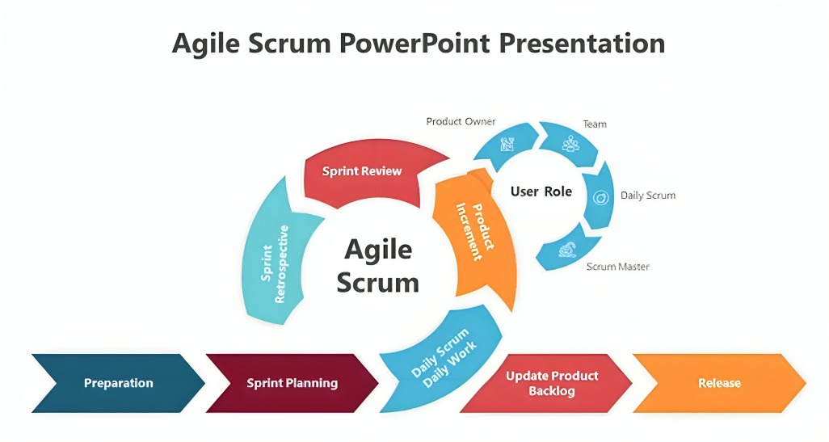

Figure 1. Agile Scrum Methodology
Agile Scrum is an iterative and incremental methodology. It emphasizes the management aspect and flexibility. Moreover, this methodology emphasizes constant feedback and delivery of work that comes in the form of software via small iterations known as sprints. Instead of building the entire system in one effort, Scrum divides the project into portions thus allowing planners to design, implement, test, and enhance the required system gradually based on the feedback received from interested parties. Therefore, the Agile Scrum allows the research team to react to changes in requirements while ensuring that with the end of every sprint a working element of the system is available.

The Agile Scrum framework proposed is started from the preparation stage. At this stage, the researchers needed to collect the functional and non-functional requirements of the Performance Review and Skill Development System with an AI-based Performance and Learning Analytics Dashboard. The findings have been achieved through the implementation of customer feedback, interviews, observations, and studies of already existing performance and development processes of the hotel and restaurant organization. The requirements received were then structured into the Product Backlog, which serves as a list of the system features and processes to be implemented.

Then, the project transitions into the Sprint Planning stage in which the researchers identify the goals as well as the scope of the next sprint. In this stage, the most important items in the Product Backlog are picked out and moved into the Sprint Backlog. The group mentions the tasks to be performed, estimates the work to be done, and allocates responsible for developing certain modules of the system that are the Performance Management Module, Competency Management Module, Learning Management Module, Training Management Module, Succession Planning Module, Social Recognition Module, and the AI-Assisted Performance and Learning Analytics Dashboard.

In this stage, researchers design the functionality of the system in the framework of Next.js, TypeScript, PostgreSQL, RESTful APIs, NextAuth.js, and OpenRouter AI algorithm. They also hold Daily Scrum meetings in which they talk about what has been done, what activities should be performed, what issues were faced and how they can be addressed.

At the conclusion of each sprint, a Sprint Review takes place to showcase the completed system increment to the project advisor and client representatives. The functionalities that were implemented are displayed, assessed, and verified to ascertain if the implemented requirements have been met. The feedback and suggestions collected during this event are recorded for evaluation in subsequent iterations.

Once the Sprint Review has been held, the team conducts a Sprint Retrospective for evaluation of the development process as a whole. During this stage, they identify the effective practices that they applied, enumerate the challenges and hindrances they have faced during the Sprint, and suggest the ways for the improvement of the processes.

The refinement of the Product Backlog leads to the update of the current requirements, introduction of new demands to the task list and adjustment of the priorities according to the information obtained from the reviews. The process of refinement allows the team to be sure that in the future sprints, all needs of the client will comply with the objectives of the project. Once all modules outlined in the plan are completed and passed through testing, the system goes to the Release stage involving the presentation of the finished Performance Review and Skill Development System, along with its AI-Assisted Performance and Learning Analytics Dashboard.

The Agile Scrum methodology is suitable for use in the present research project, as the proposed system involves a lot of modules related to one another and requires incremental development. The iterative sprints allow researchers to continuously get feedback from stakeholders and develop the modules of Performance Management, Competency Management, Learning Management, Training Management, Succession Planning, and Social Recognition. This method helps to reduce risks in development, improve the quality of the product, and ensure that the particular system will be effective in enhancing employee performance management.

2.4.1 Microservice Architecture
Microservice Architecture builds an application as a collection of small independent services with each and every service having their own focus on a specific business task that can be updated, deployed, and can be scaled without affecting the rest of the app. Now this kind of Architecture applies in every field in today's condition, and one of those is the Hotel and Restaurants that plays a crucial role in developing and improving a city's status in terms of wonders.

According to Kaul, D. (2023), Microservices architecture is a software architecture comprising AI functionalities that are divided into discrete services responsible for performing a particular task, say pricing, forecasting, or allocation- adds great complexity to the system since all services need to be tuned against possible conflicts or discrepancies in the data. Microservices architecture breaks down the AI system‎ into small, independent services, each with a discreet task relative to AI-for example, price optimization, demand forecasting, or guest‎ segmentation. Using this model allows the various services to scale, validate, and modify themselves without negatively affecting the operation of the overall system. Hotels that take advantage of this type of AI use will be able to adapt to market changes, customer needs, and competition more quickly and efficiently.

2.4.2 Artificial Intelligence (AI)
Artificial Intelligence (AI) has become a crucial technology in Human Resource Management (HRM) activities while providing data-driven support for organizational decision-making. As argued by Tuffaha (2023), the application of AI in HRM has expanded to many areas such as hiring and staffing, performance management, compensation, as well as training and development. Contrary to the general assumption, AI does not replace HR professionals; instead, it serves as a complementary technology that improves productivity by managing large amounts of employee data, offering suggestions for HR decisions, and improving HR process management.

Nevertheless, the research highlights that organizations should use AI cautiously because AI may pose risks to HR processes if AI bias is not properly managed. Tuffaha (2023) discusses that AI is being increasingly used in HRM in order to manage massive amounts of information about employees in the workplace to aid the work of HR specialists in different organizational processes.Through a systematic literature review of 34 selected studies, Tuffaha (2023) concluded that AI has been applied to support decision-making by analyzing workforce data. These applications include hiring, staffing, performance management, compensation, and employee training and development.Tuffaha (2023) identified that the quality and design of AI-enabled systems determine the fairness and effectiveness of HRM.

Tuffaha (2023) noted several benefits of AI in HRM, including increased efficiency, faster information processing, improved decision-making, and better management of HR tasks. However, it is also crucial to consider different source(s) of AI bias, including data biases, method biases and socio-cultural biases- in the system’s operation so that fairness, transparency and accountability can be achieved in HRM. Thus, the role of AI in HRM is primarily to support HR professionals in making informed personnel decisions.

2.4.3 Internet of Things (IoT)
IoT technology is a critical technology backing big data. It influences companies to improve operational processes and make better decisions. However, as powerful as it is, IoT usage in the field of Hospitality and Tourism (H&T) is limited, and the information on its application is quite contradictory.This study aims to examine the concept of IoT, along with its benefits, challenges, and applications within the hospitality industry.

According to Anjali Abasaheb Sabale, R Subashini (2024), the rapid evolution of technology has transformed many industries, including human resource (HR) management. Organizations have started to use Artificial Intelligence (AI) and the Internet of Things (IoT) in order to enhance the functioning of their businesses. Using AI and IoT helps organizations to automate their operations and make use of more accurate decision-making processes in human resource management operations. These tools allow the firms to utilize more intelligent and data-based decisions in human resource management. The research will study how AI and IoT can help in improving human resource management and what advantages and disadvantages exist concerning the application of these technologies in HR.

2.4.4 Data Analytics and Business Intelligence

Data Analytics and BI complement one another as they both help organizations to transform raw data into information to facilitate operational and strategic business decision-making. Data Analytics aims to examine, interpret, and identify patterns in large volumes of data, whereas Business Intelligence focuses on consolidating, organizing, visualizing, and presenting analyzed data into reports and dashboards in order to help businesses to make decisions. According to Eboigbe et al. (2023), the introduction of BI into Data Analytics and AI has shifted traditional data processing into an AI enabled predictive analytical process so organisations can produce better accuracy information, making efficient data based decisions in a timely manner.

The study also went on to describe that Business Intelligence involves the collection of data from across various organizational sources, analysing and processing the collected information utilizing data analytic methodologies, finally presenting the outcomes to end users in forms of reports, dashboard and visualizations. Through BI incorporation and AI application, Business Intelligence has transitioned from analyzing historical data to predicting trends to supporting planning as an enterprise, organizations continuously monitoring business processes, spotting trends, and predicting future outcomes to boost efficiency through evidence based management (Eboigbe et al., 2023).

Finally, Eboigbe et al. (2023) also stresses that through an integration of BI and Data Analytics the organization can benefit greatly from Business Intelligence. The adoption of BI along with Artificial Intelligence improves the effectiveness, the precisions, and the ability to make forecasts based on organizational processes by changing massive volumes of organizational data into information that facilitates operations. It allows the organization to optimize business operations, to monitor an organizations’ performance, discover trends, and develop future plans based on factual evidence rather than assumptions. Real-time analysis and foresight from the perspective of a Business Intelligence allows businesses to effectively react to shifts in the environment and improve the overall decision-making quality (Eboigbe et al., 2023).

The insights gained above support the P&DSS in explaining how data gathered on employee performance, competence and learning can be transformed into useful information for HR administrators, just as demonstrated by Eboigbe et al. (2023). The subsystem gathers and consolidates employees data, it analyse the information using the techniques identified in Data Analytics, before representing the outcome through dashboard and analytical reports which will help HR administrators to provide performance feedback to their employees as well as to guide them in providing support for their employees’ development and that of performance and skills. Also, with the application of AI and analytics in BI, HR administrators could monitor the trends in the performance and skills development of the employees, hence the P&DSS provides valuable assistance for HR administrators when evaluating employee’s skills, performance, training and competencies before coming to a final HR administrative decision, where a human operator’s input is indispensable.

2.4.5 Polyglot Persistence
Modern systems based on data and tailored for the cloud work with various datasets that cannot be managed effectively by one type of database. Often, single databases cannot manage different types of data, their formats and types of access. To illustrate, an online sales platform might involve the usage of a relational database for transaction records, document storage for product catalogue and a graph database for product recommendations. It is impossible to solve the problem of diverse workloads by means of one model only.

Polyglot persistence, introduced by Fowler, deals with the problem by allowing the usage of different types of database technologies within the same system and providing the option of choosing them based on particular advantages. In distributed and microservice systems, this would mean that ACID-compliant rational base systems would be utilized together with NoSQL technologies, ensuring horizontal scalability, flexible schema and high speed operations. Document and column databases support semi-structured data while key-value bases enable database search in less than a millisecond and graph databases allow reasoning over complicated relations.

Yet, the introduction of polyglot persistence opens new questions. Distributed systems very often rely on eventual consistency principles involving explicit synchronization and cooperation of different bases. Developers have to work with CAP theorem limitations when dealing with the issues of consistency, availability and tolerance to partitioning. Additionally, with the increase in the number of database systems, additional operational problems also arise as this requires deep knowledge of how to set up, program and protect new technology (Barman, U. & Joshi, K. 2025).

The need for multiple types of database implementation arises from the complexity of modern applications that sometimes require functionalities that cannot be fulfilled by only one type of database system, as stated in Mosquera et al. (2025). Framed in a concept called polyglot persistence, one can integrate various types of data storage technologies into a single application for efficient data management.

However, take note that polyglot persistence increases complexity in design and implementation, thus raising programming complications and requiring mastering various programming languages. Polyglot persistence comes into play in this study, and the implementation of such technology ensures the scalability of the system through the separation of common transaction processes from heavy analytical processing. While a relational database acts as a means to guarantee data integrity in terms of the performance feedback and core employee profiles, a certain type of data storage is used to process unstructured and high-speed data vital for the AI-based Learning Analytics Dashboard.

2.4.6 Cybersecurity
Cybersecurity is the protection of system, network, application, computer systems, devices and information from cyber attacks, unauthorized access, cyber threats and data breaches. As per Schiliro (2023), cybersecurity refers to those efforts being employed to safeguard the computer systems, networks and other devices from cyber-attack and threat. To achieve Cybersecurity, one has to identify potential threats, adopt some set of controls to address such threats like authentication and data encryption, continuously monitor the systems for any suspicious activities or incidents and keep patching the security controls for vulnerability. According to Dalal et al. (2022), together with technology, human behaviour and compliance to company’s security policies plays an essential role in overcoming cyber threats, as humans are the most frequent source of cybersecurity incidents.

These measures are essential for averting access to the HR data by cyber threats (Manoharan, 2024) , thus improving an organization’s data privacy and user confidence while enabling confident decision-making based on reliable data, also integrity, availability, and confidentiality of data is guaranteed (Balzano, 2024). Cybersecurity is a vital requirement for the developed system as it will deal with the sensitive employee data such as personal details, performance appraisals, competencies and skills, training and development. Measures such as access control by roles, authentication by login, data encryption, audit logs and constant monitoring of the systems have been employed to keep employee records secure.

2.4.7 Data Privacy
Data privacy involves collecting, using, storing, and safeguarding personal information appropriately so that only authorized users can access and only legal purposes can be made of such information. Data privacy as stated by Kumar et al. (2024), is protecting employee information which is an integral duty of all the companies. Data privacy includes only acquiring relevant information, using access restrictions by implementing the required authorities, appropriately storing records, monitoring how the data has been used, and adherence with specific policies set by a privacy statement. Data privacy principles contribute to protecting employee’s private information from getting disclosed through different malicious attacks, thus bolstering employee confidence, meeting with requirements and regulations in addition to bolstering employees trust in the HR information system, as described in Kumar et al. (2024). In this study, data privacy is essential because the proposed system will keep all of the classified data concerning the employee, comprising personal information, appraisal details, employee competency level, training particulars, employee development career progression details. The information regarding employees can be securely managed by taking necessary measures for data privacy such as applying user authorization using roles, data encrypting and providing secured authentication to access information, data backups as well as establishing robust data governance as mentioned by Rahman et al. (2025).

2.4.8 Software Quality Standards
The Software Quality Standards are a collection of criteria and indicators that are used to ensure the quality of any given software product and its conformity to the needs of users and business objectives. Software Quality Standards include not only technical aspects, but also usability, performance in tough conditions, security, and sustainability of the code in the long run. They are the rules of how to write clean code and get rid of bugs in it.
As the time progresses the use of Software Quality Standards also became important for this can unify the quality requirements, guide evaluation across the software life cycle, and improve reliability, efficiency, cost control, and organizational performance. Furthermore, the report also point out that apart from the use of standards and evaluation, their performance is dependent to some extent on influencing employees' skills and behavior, because successful quality ensuring requires not only the use of standards and evaluation but also communication and cooperation, continuous learning, and soft as well as hard skills of the team members according to Ozaya, I. (2021).
In addition to the above, the Software Quality Standards provides a consistent structure that can define, measure as well as evaluate a software quality, thereby assisting organizations to mitigate the risks associated with development, implementation, and maintenance. Standards also can create conditions for efficient, cost-effective, secure, and reliable software, while improving planning, monitoring, documentation, and continuous improvements. According to Gezici, B., & Tarhan, A. K. (2022), the widespread demand for Artificial Intelligence (AI) software, specifically Machine Learning (ML) is getting increasingly popular and being adopted in various applications we use daily. AI-based software quality is different from traditional software quality because it generally addresses distinct and more complex kinds of problems. With the fast advance of AI technologies and related techniques we can now learn how to build high-quality AI-based software that can become a very prominent subject in different aspects.

2.4.9 Cloud Computing
As explained by Maqueira Marín et al. (2022), cloud computing has become an important technology in Human Resource Management (HRM). It enables organizations to store, manage, and retrieve HR information using Internet-based resources instead of on-premise systems. Moreover, Maqueira Marn et al. (2022) stated that it enables organisations to improve the flexibility and accessibility of HR service delivery, and provide a holistic view of an organization’s HR information. According to Maqueira Marn et al. (2022), cloud computing has emerged as a critical facilitator of the digital transformation of HRM due to its widespread adoption of cloud-based HR systems and enhanced organizational performance.

In relation to how the cloud computing in HRM works, Maqueira Marn et al. (2022) indicated, “the cloud computing service stores the data on centralized cloud servers, through which authorized users can access, store, and modify data over the Internet, store it and modify it, all of which implies centralising employee information. Four areas have been found regarding the applications of cloud computing in HRM: Cloud-based HR Platforms; Human Resource Elasticity; the adoption and implementation of cloud-based HR systems; and the Organisational effects of cloud computing. These processes enable the centralization and accessibility of employee information across the organization.

On the other hand, Maqueira Marin et al. (2022) suggested that cloud computing offers several advantages, including improved accessibility, flexibility, cost-effectiveness, scalability, and easier access to shared resources. By storing employee’s HR data in the cloud, the organisation reduces costs on hardware and software and maintenance of HR IT infrastructure and authorized HR personnel can access real-time employee data from any location. As a consequence, the organisational performance is enhanced through improved info sharing, managing people and decision-making on a timely basis due to the instant availability of reliable data and information regarding their employees.

These points strengthen the P&DSS proposal as it highlights the possibility of securely managing and retrieving employee data of performances, competencies, learnings, training and development records within a central repository that operates on a cloud-based system. In parallel with the cloud based HR system mentioned by Maqueira Marin et al. (2022), The P&DSS allows any HR officer, using internet connection, access and manage employee information related to performance, competencies, learning, and training at any time. It provides timely access to performance records, and information concerning their personal developments, while ensuring that HR administrators retain responsibility for all final HR decisions.

2.4.10 Edge Computing
Edge computing has emerged as a new computing paradigm due to the rapid advancement of communication technologies and the widespread adoption of mobile devices by Deng et al. (2020). At the same time, artificial intelligence (AI) has experienced significant growth because of breakthroughs in deep learning and improvements in hardware capabilities. The enormous amount of data generated by edge devices creates increasing demands for efficient data processing and optimized system performance. As a result, the integration of edge computing and AI has led to the development of edge intelligence. This concept can be categorized into two areas: AI for Edge, which applies AI techniques to improve the efficiency and performance of edge computing systems, and AI on Edge, which focuses on performing AI tasks such as model training and inference directly on edge devices. This area brings together edge computing and AI as it creates new opportunities for research and innovation, providing a basis for future advancements in edge technology.

The researchers Kong et al. (2022) in their study mentioned that edge computing has been a critical tool in solving the problem due to a large influx of data brought about by the massive number of devices connected at the present time (Internet of Everything, 2022). With its ability to process data near its origin, edge computing works in relieving network overload and improving performance. Despite the fact that the idea of edge computing has amazing abilities, this technology faces many challenges related to the principles of service transfer and the protection of secrecy and security in addition to the implementation of edge nodes.

2.5 DevOps Culture and CI/CD Practices
DevOps is the bundle of applications and culture activity that focuses to separate the challenges between evaluation and performance associates to boost participation and communication. It is a pack of applications and civilization morals and the major goal is to combine the companies, extract challenges, boost cooperation, and liaise in a productive method linking with evaluation and functioning coordination. It is also a mixture of structures to boost collaboration and association linking with developers and functioning teams to inscribe risky challenges throughout the progress of software by Khattak, K. et al. (2023).

The Continuous Integration/Continuous Delivery (CI/CD) is, on the other hand, the main automated engine that powers the process and allows developers to write code, test it automatically for sustainability, and deliver it to users effectively and securely. They serve as pivotal in modern software development. Shifting from the classic waterfall models, the current age is dominated by Agile methodologies and DevOps practices by Thatikonda, V. K. (2023). The DevOps and CI/CD practices have an important role because before these practices, teams built codes in isolation which led them to merge large chunks of code weeks later, which resulted in major bugs and delayed releases. That is where they take action with the consistency in speed for frequent updates that can get features to users as much as faster than massive, risky updates. Safety, for automated testing catches bugs early in the pipeline while the changes are still fresh in the developer's mind, and Collaboration for developers and operations teams share the same automated workflows, everyone takes joint responsibility for system health by Arugula, B.(2021).

Arugala, B. (2021) Stated that the use of DevOps and CI/CD have transformed big companies trying to improve their software delivery speed, dependability & also teamwork. By uniting the development and operations teams, DevOps is a technical & cultural change that can promote constant automation and even more collaboration in the future. A basic tool in this approach, Continuous Integration and Continuous Development/Deployment (CI/CD) guarantees automatically built, reviewed & delivered with little human participation, therefore guaranteeing code changes.
Using these methods helps large companies supervising complex systems and large development teams to enhance product quality, lower time-to-- market, and reduce human errors.

2.6 Enterprise Architecture and System Integration
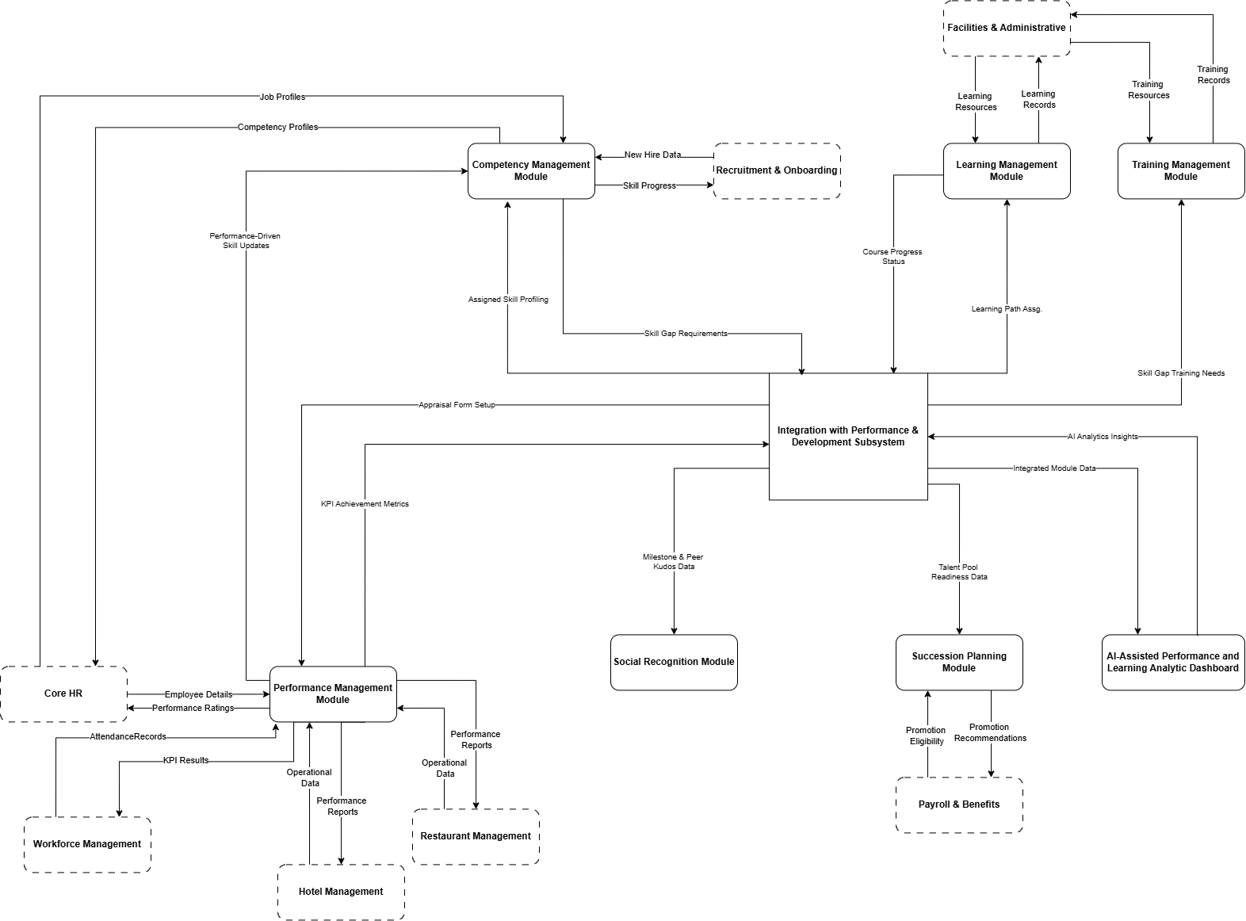
The Performance and Development Subsystem is identified in the Human Resources Management system proposed in the context of the Hotel and Restaurant Business System. It allows for multi-directional communication with other subsystems designed for data-related needs of personnel working in the organization. The incorporated subsystem works in compliance with the objectives of the organization itself due to the outlines and objectives adopted in the AI-Assisted Performance and Learning Analytics Dashboard.

Figure 2. Enterprise Architecture and System Integration

The suggested subsystem of performance and development is an integrated part of the system of hotel and restaurant businesses, not an independent application. It interacts with several components of the enterprise solution for data collection regarding the organization, processing information regarding employee performance and development, and rendering guidance for human resource management.

To get employee data, competency profiles, organizational assignments, and job descriptions necessary for performance evaluation, the system communicates with the Core HR subsystem. After the evaluation of employees is completed, updated performance indices are fed back into Core HR to ensure that employee data is kept up to date.

By communicating with the subsystem of workforce management, it is possible to get the data related to employees' attendance, information about their leaves, and other indicators necessary for the evaluation of the staff by KPIs. The subsystem provides data about KPIs in exchange.

The subsystem communicates with the Recruitment and Onboarding subsystem to receive information about newly hired employees and initial competency information. The competence progress is transmitted back as soon as employees pass their competency assessment tests and training programs.

For the purpose of continuous employee education, the subsystem interacts with the Facilities and Administrative subsystem to get available education opportunities and training materials. Information about the use of training and course completion will be sent back for documentation and administrative control.

The Hotel Management and Restaurant Management subsystems supply operational data, departmental responsibilities, and labor performance reports that are used during evaluation of employees’ performance. The Performance and Development subsystem generates summarized performance reports that help operational managers control performance of employees in their departments.

As far as career growth for the employees is involved, the subsystem interacts with Payroll and Benefits subsystems through its contribution in promotions recommendations and succession planning processes. Thus, performance eligibility and remuneration data are used in the process of talent pool evaluation and career readiness assessment in return.

When it comes to the subsystem, the six core modules named Performance Management, Competency Management, Learning Management, Training Management, Succession Planning, and Social Recognition are continuously exchanging data within the internal integration layer. It is through this integrated workflow that the results of the performance evaluation carry weight during the process of competency evaluation, the identified competency gaps trigger the creation of personalized learning paths, learning results help in determining the training needs of the employees, training progression in its turn ensures the proper succession planning, and extraordinary achievements of the employee make their contribution to the programs of recognition of the organization.

To conclude with, the collected information from all modules is then processed by AI Performance and Learning Analytics Dashboard featuring the OpenRouter API to create AI-based reports that present performance summaries, learning summaries, insights about competency gaps, and recommendations for individual development, as well as executive dashboards. These AI-generated insights assist HR administrators and managers in making informed, data-driven decisions while preserving human judgment in the final evaluation and development process.

2.7 Conceptual Framework
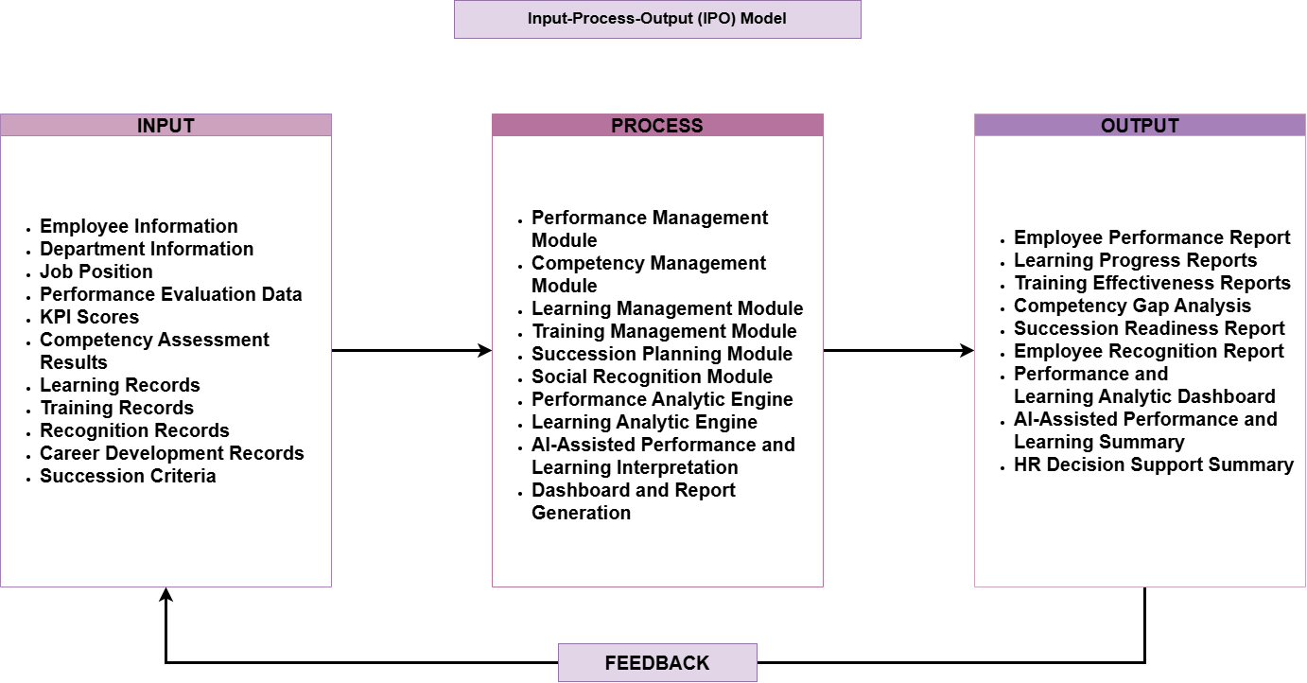
Figure 3. Input-Process-Output (IPO) Model

The IPO model serves as the basis for this study that aims on how the Performance Review and Skill Development System with an AI-Assisted Performance and Learning Analytic Dashboard is capable of turning employee and organizational data into regular information for purposes of performance management as well as gaining insights into employee development.

The first stage comprising inputs indicates the data necessary for the functioning of the system to take place. Thus, data can be represented as employee data, department data, job title, performance evaluation records, KPI scores, competency results, learning records, training records, recognition records, career mapping records, and succession planning requirements. The data can also be used as the basis for performance assessment, learning assessment, detection of competence gaps, reward accounting, and succession readiness assessment.

The Process phase embodies the fundamental functions of the proposed solution. The first one is the Performance Review Module, which ensures that employees are evaluated per the existing performance criteria and KPIs. Next is the Skill Development Module, which traces the competencies of employees and their learning and development activities. The Learning Management Module monitors learning activities and completion of development tasks, while the Training Management Module runs employee training programs and evaluates their efficiency. The Succession Planning Module identifies those employees who are ready to assume greater responsibility according to their performance, competencies, and records of development. At the same time, the Social Recognition Module manages recognition initiatives by documenting achievements and recognizing exceptional work. The next stage is processing of all the obtained information by two engines – Performance Analytics Engine and Learning Analytics Engine.

The Output phase involves the reports and information generated by the system. Some of these reports include employee performance reports, learning progress reports, training effectiveness assessment reports, competency gap analysis reports, succession readiness reports, employee recognition reports, and interactive Performance and Learning Analytics Dashboards. Moreover, the AI component also generates performance summaries, learning summaries, and development recommendations that help HR staff and managers understand the performance of the workforce and make decisions on employee learning initiatives. Such outputs allow for increased transparency, objectivity, and data-driven decisions in human resource management.

The Feedback stage completes the Input-Process-Output (IPO) cycle by subjecting the output reports, analytics, and AI-enhanced information obtained from the system to further improvement. In fact, employees, managers, and HR professionals check the reports on performance, training progress, AI recommendations made by the program, and dashboard analytics in order to assess employees’ achievements and development results. Depending on the findings obtained, HR can either update the Key Performance Indicators (KPIs), correct the performance criteria, suggest more training opportunities, or amend individual development plans in order to counter the weakness revealed in the evaluation. Thus, the information obtained may also help employees to improve their performance and learning efficiency in the subsequent evaluations.

In general, the IPO framework shows how the system integrates management of employee performance, skills development, learning management, succession planning, and social recognition into a single system. Thanks to the introduction of AI technologies, the system allows for the conversion of raw data into significant knowledge, which helps the HR specialist and managers in evaluating employee performance, training progress, and decision-making while making sure that actual decision making stays with the organization management.

2.8 Theoretical Paradigm
Algorithm | Description | Function
Role-Based Access Control (RBAC) Algorithm | Determines user access levels according to their roles mentioned (HR administrator, department head, operations manager, senior manager, and employee). Approves every request prior to granting access to modules, workflows, and information. | Implements authorization and safeguards sensitive HR data, while ensuring that users are permitted to use only authorized resources.
Authentication Algorithm | Utilizes JSON Web Tokens to verify users when they log in and approves each secured API request with the use of middleware to verify. | Ensures that only authorized users gain access to the system with secure sessions.
Workflow State Transition Algorithm | Manages employee workflow for development by ensuring movement of records through stages like review, evaluation, approval, learning, and completion. Validates every transition based on user role. | Preserves consistent HR procedures and avoids unapproved performance of moves in workflows.
AI-Assisted Performance and Learning Analytics Algorithm | Compiles scores of employee performance indicators, competency scores, learning progress, readiness for succession, and workflow records before creating analytical data and recommendations by employing an AI model. | Provides factual data that allows HR and managers to make the right decision for the company without taking the joy of making such decisions away from human beings.
Competency Gap Analysis Algorithm | Contrasts the competency measures of employees with necessary competency standards for their roles to reveal skill-gaps and developmental requirements. | Identify skill gaps and suggest suitable learning techniques and skill upgradation roadmaps.
Learning Progress Tracking Algorithm | Determines employee learning completion data based on the assigned learning modules, courses taken, and recorded training events. | Monitors the performance growth of employees and gives precise analytics for employees and HR.
Performance Score Computation Algorithm | Computes employee performance ratings by aggregating KPI indicators, supervisory assessments, and self-evaluations based on predetermined evaluation standards. | Creates unbiased performance metrics for employees to help the company’s assessments and reporting.
Succession Readiness Assessment Algorithm | The certainty that employees are ready for management positions is determined by the combination of the competency scores, the evaluation of performance, the training completion, and the development of experience. | Helps HR in identifying successors and contributes to succession planning processes.
Certificate Generation Algorithm | Create employee certificates on the basis of completion of desired training or learning requirements and validate completion records before printing certificates. | Certificates are issued correctly without the risk of unwarranted issuance or copying.
Search and Filtering Algorithm | Execute keyword search to filter employee records, workflows, certificates, learning activities and other reports based on user queries and set permissions. | Enhances the efficiency of information retrieval functions and user productivity throughout the system.
Notification Trigger Algorithm | Identify workflow events like approval pending, evaluation done, training schedule and certificate creation and build notifications for authorized users. | Provides proper communication and informs the user about significant events in the system.
Audit Trail Logging Algorithm | Keep records of the user activities such as logging in, approving processes, creating AI requests, updating records and identifying users with time stamps. | Offers monitoring, auditing, and accountability functions necessary for administration.
Table 2. Theoretical Paradigm
These algorithms that work together are the Performance Review and Skill Development System. The Authentication and RBAC algorithms give safe access to the system using identity verification and authorization. Once authenticated, a user communicates with the Workflow State Transition Algorithm responsible for workflow transitions related to performance review, competency analysis, education activities, training, succession, and recognition. The data from these modules go through a number of algorithms: Performance Score Calculation, Competency Gap Analysis, Learning Progress Monitoring, and Succession Readiness Assessment. The information obtained will be received as input by the AI Performance and Learning Analysis Algorithm which produces various analytics and recommendations. There are also algorithms that help with usability, operational efficiency, and safety e.g. Certificate Generation Algorithm, Notification Trigger Algorithm, Search and Filter Algorithm, and Audit Trail Logging Algorithm. The work of all algorithms is directed toward achieving quality features produced according to ISO/IEC 25010 standards: Functional Suitability, Performance Efficiency, Reliability, Usability, Security, and Maintainability.

CHAPTER 3
METHODOLOGY AND PROJECT MANAGEMENT

3.1 The Adapted Agile Scum Framework
This chapter describes how the Agile Scrum framework was used to create the suggested performance review and skill development system that includes the AI-supported Performance and Learning Analytics Dashboard. The Agile Scrum methodology was chosen because its iterative and collaborative nature makes it possible for the research team to implement functional components of the system in iterative development while still taking into consideration feedback from the stakeholders.

The framework serves as a roadmap for the implementation of the project by providing the details about the activities, roles, and processes performed at different stages of planning, designing, developing, testing, evaluating, and improving the proposed system. Every major component of the system, including the Performance Review Module, Skill Development Module, AI-based Performance and Learning Analytics Dashboard, features that deal with the reporting and user management, will be implemented, evaluated, and developed iteratively.

The researchers are trying to modify the Agile Scrum framework according to the demands of this particular study in order to achieve systematic project management, facilitate collaboration among team members, minimize development risks, and develop the software solution that meets the high standards and works fruitfully for employee performance evaluation, skill development, and Human Resource decision-making in hotel and restaurant organizations.

3.1.1 Team Roles and Responsibilities
The Project Manager, System Analyst, Lead Developer, Quality Assurance (QA) Tester, and Document Analyst play a vital role in the management and support system for the development of a proposed Performance and Development Subsystem (P&DSS). In order to achieve success in delivering the project, team members execute different tasks and roles according to their specialization. Team members collaborate, coordinate, and communicate with one another to accomplish the successful delivery of the project.

Team Member | Role | Description
Celsi A. Garcia | Project Manager | In this position, the Project Manager can supervise project planning and coordination. The Project Manager will ensure the timely completion of projects, create assignments for team members, and control the execution of work.
Eymard C. Buyser | System Analyst | The System Analyst has a job to collect, evaluate, and document the needs of the system. This position reviews the current HR processes, determines the requirements of its users, writes specifications for the system, and creates system models to confirm that the new system satisfies the needs of the organization.
Yuan A. Amboy and  Celsi A. Garcia | Lead Developer | The Lead Developer is in charge of conceptualizing, creating, and implementing main features of the Performance and Development Subsystem (P&DSS).  This position supervises the activities of the frontend and backend developers, database developers, dashboard developers, and developers of Artificial Intelligence (AI) decision-support capabilities. The Lead Developer makes sure that the system works effectively and securely following the approved requirements of the system.
Jannah Mae Nueva | Quality Assurance (QA) Tester | Responsible for ensuring the quality of the proposed system, the Quality Assurance (QA) Tester is tasked with reliability and functionality testing. The position involves functional testing, integration testing, user acceptance testing, documentations of the test results, reporting of the issues, and verifying that the defects have been corrected before the intended system is deployed.
Hexa B. Anonuevo | Document Analyst | The responsibility of the Document Analyst includes preparation, organization, and maintenance of documentation for all projects. The tasks performed by this position include writing and maintaining the capstone manuscript, technical materials, user guides, and testing reports while complying with the standards of academic documentation and ensuring consistency and correctness.
Table 3. Team Roles and Responsibilities

3.1.2 Scrum Events
The development of the proposed Performance Review and Skill Development with an AI-Assisted Performance and Learning Analytics Dashboard lies on the Scrum methodology that organizes the process into iterative sprints. Every Scrum event serves as an occasion for planning, collaboration, ongoing improvement, and getting feedback from stakeholders to ensure that the designed solution satisfies the needs of the partner's hotel and restaurant company.

Scrum Event | Purpose in the Proposed System | Timebox | Frequency | Expected Outcome
Sprint | Create and implement usable advances in the Performance Review and Skill Development System that achieve the objectives of the sprint, like one or many modules or dashboard functionalities. | 2-3 Weeks | Repeated until project completion | A full-tested and operational increment of a system available for customer assessment.
Sprint Planning | Establish the sprint goal, set the priorities of the Product Backlog items, and designate development tasks of the selected modules (like Performance Management, Competency Management, Learning Management, Training Management, Succession Planning, Social Recognition, and AI-Assisted Analytics Dashboard). | 3-4 Hours | Once at the beginning of every sprint | A Sprint Backlog referring to all the operations planned for the Sprint.
Daily Scrum | Supervise the daily activities of the team, inform about the tasks accomplished, discuss possible technical problems, and coordinate the development process of frontend, backend, database, AI integration, and module development. | 1 Hour | Daily during the sprint | The enhancement of the communication process in the team, the detection of the problems at an early stage, and the successful implementation of the Sprint goals.
Sprint Review | Show the stakeholder and the client the completed functionalities of the system, collect comments, and check if the modules are implemented as per the functional requirements of the Performance and Development Subsystem. | 2 Hours | Once at the end of every sprint | Responses from the client, confirmed features of the system, and a modified Product Backlog for further Sprints.
Sprint Retrospective | Evaluate the success of the sprint by finding the works that were done well, problems during development and testing, and possibilities of relying on better cooperation practice, better programming regulations, and project management. | 1-2 Hours | Once after every Sprint Review | The continuous enhancement of the development process and an increase of the team’s efficiency in the upcoming Sprints.
Table 4. Scrum Events
3.1.3 Scrum Artifacts
A system's development process can be made transparent by using Scrum. This means tracking what the project must do; the output achieved so far. Scrum helps to keep the development process under control and to ensure that the project is following its main goals and objectives.

Product Backlog
The Product Backlog is a prioritized list of all the features, system requirements, enhancements, and technical tasks required to develop the proposed Performance and Development Subsystem (P&DSS). It includes modules such as assessing employee performance, managing competencies, learning and growth, artificial intelligence (AI) based decision assistance, dashboard analytics, and user management. The Product Backlog was continuously updated during the project when new clients' demands were discovered and the feedback from stakeholders was taken into account.

Sprint Backlog
The Sprint Backlog comprises the chosen Product Backlog entries the development team has promised to complete in that particular Sprint. This contains the various tasks, responsibilities assigned to the various team members, and deadline estimates. While the P&DSS was being developed, this Sprint Backlog guided the team’s daily activities, and it also enabled members to monitor project progress, while completing the planned functionalities for each sprint.

Increment
The Increment refers to the completed and functional portion of the proposed Performance and Development Subsystem produced at the end of each sprint. Each increment represents a working version of the system developed, tested, and validated according to the team’s Definition of Done. The completed functionalities were shown in the Sprint Review for evaluation and stakeholder feedback.

3.1.4 Toolstack
A certain collection of technology and tools was used to develop the system to facilitate each stage of the Software Development Life Cycle (SDLC), such as design and development, testing, implementation, and support. This collection is called a toolstack. A toolstack is defined as the totality of technologies and systems that a company together with its developers use during all the phases of the development cycle. The toolstack chosen by the team allowed designing, developing, testing, and deploying the frontend and backend of the application, organizing the processes of data processing and collaboration with other developers, and ensuring web deployment of the application.
Layer | Technology
Frontend | React 19 + Vite + React Router 6 + Tailwind CSS 4
Backend | Node.js + Express.js
Database | PostgreSQL (with pg driver)
Authentication | JWT (jsonwebtoken) + bcrypt password hashing
Validation | Zod schemas
AI | OpenRouter API (default openai/gpt-4o-mini) for insight generation and chatbox
Security | Helmet + CORS restrictions

Table 5. Toolstack

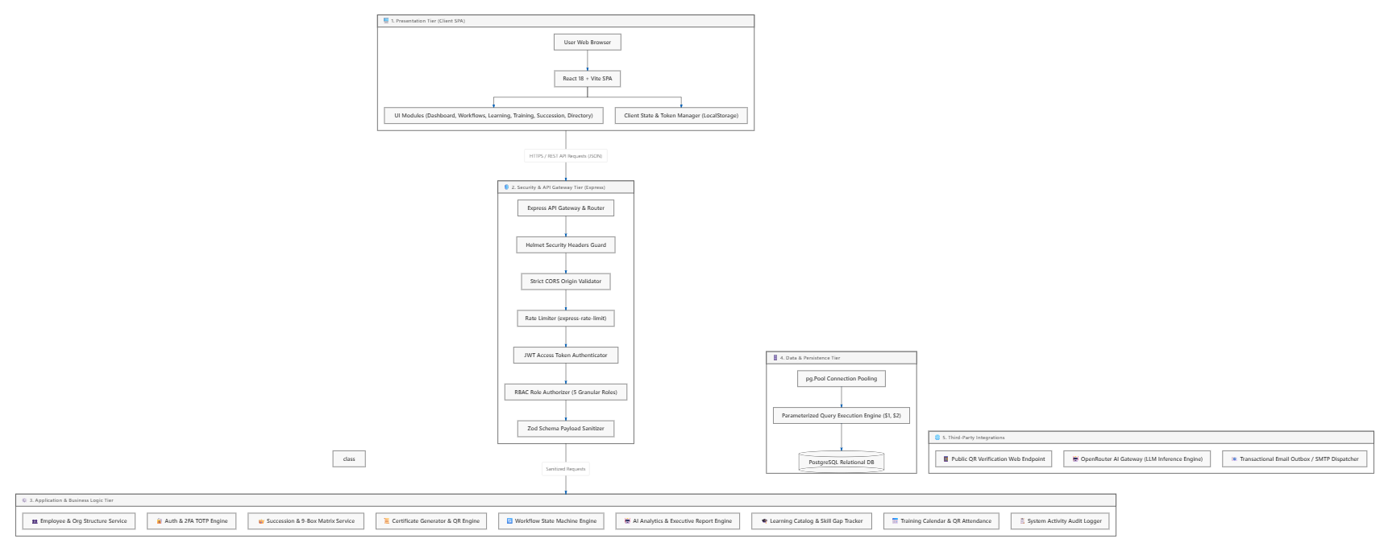
3.2 Architecture Design Decision

Figure 4. System Architecture
The structure of the planned Performance Review and Skills Development System along with the Dashboard for AI-Assisted Performance and Learning Analytics was created in a way to provide maintainability, scalability, and safety and allow integrating it smoothly into the overall Hotel and Restaurant management system. As this system is concerned only with the Performance and Development area of business, it is built as a Modular Monolithic Application which can work as a single Performance and Development Microservice by being a part of the Microservices Architecture of the given company.

The researchers chose Next.js as the framework for both front-end and back-end to minimize the development of the application by means of one technology stack. Next.js achieves the effective implementation of user interfaces, RESTful APIs, server-side processing, and application routing allowing complexity simplification and the improvement of maintainability.

PostgreSQL has become a central relational database for data management, owing to its dependable and scalable system, robust security capacity, and effective structured human resource information handling abilities. The data stored in the database includes records of employee performance evaluations, competency assessments, learning records, training records, succession planning information, social recognition records, etc.

The authentication and authorization processes for users are implemented through NextAuth.js, which has been designed to be a secure application that provides login, session management, and Role-Based Access Control (RBAC) features using authentication and authorization-related functions. In total, five user roles can be distinguished in the system: HR Administrator, Department Head, Operations Manager, Senior Manager, and Employee.

The subsystem consists of six integrated modules: Performance Management Module, Competency Management Module, Learning Management Module, Training Management Module, Succession Planning Module, and Social Recognition Module. The modules apply the same business logic and a centralized database, therefore allowing them to exchange information efficiently while performing their functions.

To support data-driven Human Resource management, the system features the AI-Assisted Performance and Learning Analytics Engine which operates through the OpenRouter API. The engine uses information on employee performance records, competency assessments, learning experience, training results, succession planning data, and recognition records to provide such outputs as performance summaries, learning summaries, competency gap analyses, and development recommendations. The findings of the AI system can be accessed through the AI-Assisted Performance and Learning Analytics Dashboard that assists HR representatives and managers in assessing employee performance and the consequent decision-making process.

The analyzed architecture combines simplicity and efficiency, with the Modular Monolithic Architecture providing a platform for simple development and maintenance in the capstone project while ensuring that the subsystem interconnects smoothly with the overall Hotel and Restaurant Enterprise Microservices Architecture via RESTful APIs. The architecture outlined above also allows for the future growth of the enterprise system without making drastic changes to the Performance and Development subsystem.

3.2.1 Why Microservices? Justify the choice over Monolithic Architecture.
The proposed Hotel and Restaurant Enterprise System adopts Microservices Architecture due to the composite nature of the system which comprises different independent business domains such as Recruitment and Onboarding, Core Human Resource, Workforce Management, Performance and Development, Payroll and Benefits, Financial Management, Supply Chain and Inventory Management, Fleet and Transportation Management, Facilities and Administrative Management, Hotel Management, and Restaurant Management. Each business domain executes its unique functions and can be developed, deployed, maintained, and scaled without affecting the operation of other connected services.

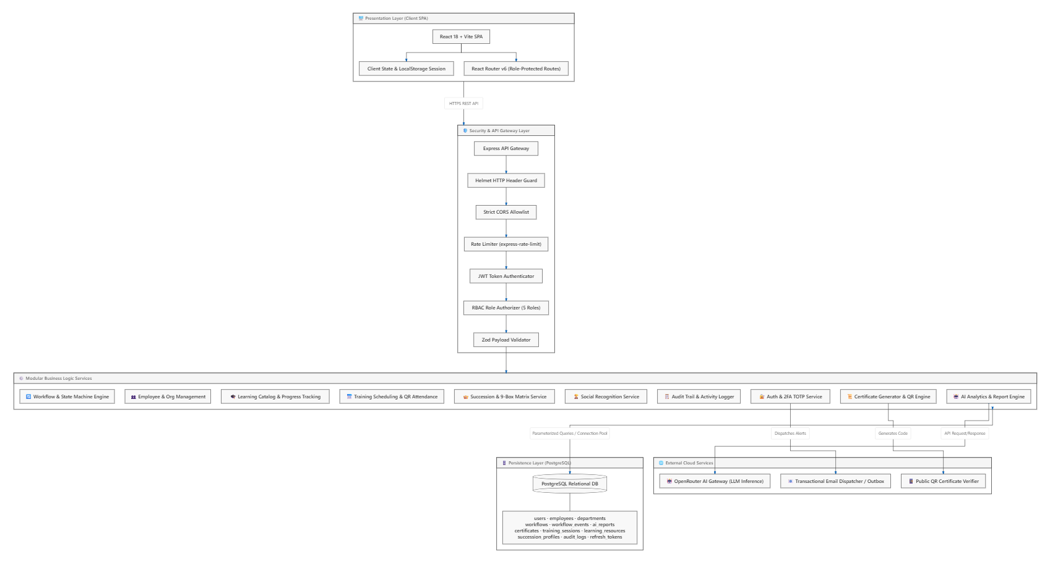
Microservices architecture offers greater flexibility for a large scale enterprise system where every module can grow independently based on organizational requirements. It also enables a number of development teams to work simultaneously on several services enabling reduction in conflicts during development and enhancement of productivity. Service communication is realized through RESTful APIs which are managed by the API Gateway ensuring that the data exchange is secure and each service operates independently from each other. In addition each microservice uses its own database thereby eliminating data interdependence and reducing the effect of failures on the system.

Figure 5. Monolithic Architecture
Meanwhile, a Monolithic Architecture where all business processes are combined in a single software application that uses the same codebase and database. This model implies that development is simplified regarding small-scale applications. However, maintaining this architecture becomes difficult when the number of modules grows. In addition, when one of the components fails or is changed, it produces problems for the entire solution and slows down development and deployment processes.

Despite the fact that the overall Hotel and Restaurant Enterprise System uses a Microservices Architecture, the Performance and Development module described in this article is created according to Modular Monolithic Architecture principles. This module consists of tightly connected components, including Performance Management Module, Competency Management Module, Learning Management Module, Training Management Module, Succession Planning Module, and Social Recognition Module, which belong to the same business domain and which are using one authentication method, common business logic, and one PostgreSQL database.

This method of architecture combines the benefits of various approaches. The enterprise solution enjoys such features of microservices as scalability, maintainability, and independent deployment, while the suggested Performance and Development subsystem benefits from simplicity, lower deployment complexity, ease of maintenance, and effective sharing of data of modular monolithic systems. Therefore, the subsystem might represent one single Performance and Development microservice in the large-scale hotel and restaurant enterprise system though keeping its clear internal modular structure.

3.2.2 Core Architectural Pattern Used
The Performance and Development Subsystem is created using the Modular Monolithic Architecture, which is a part of the larger Microservices-based Hotel and Restaurant Enterprise System. While the overall system is composed of different independent microservices, the Performance and Development Subsystem has to be developed as a single system since all sub-modules are part of the same domain of Human Resource, having more or less common business processes.

The subsystem consists of six functional modules, including Performance Management, Competency Management, Learning Management, Training Management, Succession Planning, and Social Recognition modules, and has a common backend developed using Next.js, the same authentication service developed with NextAuth.js and one single PostgreSQL database. Instead of developing the modules as independent subsystem services, they are all developed as one subsystem, thus allowing modules to use one common business-oriented logic.

The architecture includes a Performance and Learning Analytics Engine powered with artificial intelligence, which analyzes performance metrics of the employees including performance evaluations, competency assessments, training records, and recognition information contained in the database. The insights received from the engine such as analyses of competency gaps and summaries of performance are then displayed on scores given to the HR department, managers, and employees of the company.

This design pattern is chosen because it allows for better development and implementation process while helping to integrate the components of the subsystem easily. At the same time, it is possible to work with data of the component’s microservices through REST APIs.

3.3 Development, Operations, and Quality Assurance (QA) Methodology
The implementation of the suggested Performance Review and Skill Development System along with the AI-Assisted Performance and Learning Analytics Dashboard employs an integrated Development, Operations, and Quality Assurance (DevOps and QA) approach that guarantees not only the successful creation of the software but also continuous testing, consistent deployment, and high quality of the end product. This method allows for the collective efforts of the developers while ensuring the effectiveness of the system at every stage of its construction.

In the course of development, the development team creates the application from Next.js performing both front-end and back-end functions. The application is implemented in six blocks of information: Performance Management, Competency Management, Learning Management, Education Management, Succession Management, and Social Recognition. In addition, RESTful APIs are created for sending information between front end, back end, databases, AI services and other software systems. The centralized PostgreSQL database stores employee data with respect to things like performance, competencies, learning process, training, and succession planning. NextAuth.js has been used to implement secure authentication and authorization mechanisms with the help of role-based access control (RBAC).

GitHub provides researchers with both a collaboration tool and a version management system for their project. It makes the development process collaborative, assists in tracking versions of the project, integrating code and managing changes throughout the process. When a specific feature is finalized, it is then reviewed and integrated into the main development version of the project.

In terms of Operations, the proposed system will be containerized using a technology called Docker. Containerization is useful in minimizing configuration differences between development and deployment environments and easing deployment of the application. Once developed, the application is deployed using Vercel service which automates deployment and hosting of Next.js applications. Thanks to this deployment method, the application gets updated regularly while still being available.

The AI-Assisted Performance and Learning Analytics Engine has been incorporated into the subsystem via the OpenRouter API, using a freely available language model to prepare performance summaries, learning summaries, analyses of competency gaps, and recommendations for development. The results produced by AI technology are provided through the AI-Assisted Performance and Learning Analytics Dashboard to help HR personnel and managers assess employee performance and learning data. The AI system functions as a decision-support system, and will never replace managerial decision-making.

Quality Assurance practice is conducted throughout the software development life cycle to ensure compliance of the proposed system with both functional and non-functional specifications. Unit Testing is implemented by the researchers to check the correctness of functions within individual modules, followed by Integration Testing to ensure that the Performance Management, Competency Management, Learning Management, Training Management, Succession Planning, Social Recognition, authentication, database, and AI subsystems can communicate with each other. System Testing is then carried out to test the entire integrated application in terms of functionality, performance, security, data privacy, and usability. Lastly, User Acceptance Testing (UAT) takes place with HR personnel, managers and supervisors and employees from the partner organization to see whether the developed system meets organizational requirements and supports actual Human Resource performance and development processes.

The goal of the researchers is to merge software development, deployment and ongoing quality assurance into a single process and thus create the Performance and Development subsystem that would be secure, reliable, maintainable and scalable, while being easily integrated into the wider Hotel and Restaurant Enterprise System and providing data-driven Human Resources management using AI analytics.

3.3.1 DevOps Toolchain
The development of the system followed a DevOps toolchain to establish a structured and collaborative software development process. A DevOps toolchain is the range of tools which work together to manage and integrate some or all of the phases of Software Development Life Cycle (SDLC) to help the team to better plan, code, build, test release, deploy, operate and monitor software applications. These tools together allow a development team members to work in a closely collaborative environment and efficiently and effectively deliver software on time. It should speed up software delivery and also make software more quality, maintain, and reliable.

In the planning phase, the goals of the project and development timeline were determined, as well as what tasks were assigned in anticipation of system development prior to the commencement of development activities. The capstone chapters and scheduling for completion of development work were created using the iGanttChart to organize development schedules and track the progress for the capstone. Messenger was the major communications channel to which the tasks were assigned, issues were discussed, activities coordinated and communication among the team conducted during the entire phase of project development. Virtual meetings were done by Google Meet to cover project scope requirements among group members.

The coding phase involves creating the frontend and backend functionality for the system as suggested. Visual Studio Code served as the main Integrated Development Environment (IDE) for writing, editing, and testing the source code. The Next.js framework was used as one of the major front-end and backend building tools to generate the user interface as well as its server-side logic to help make the user interface respond quickly. To develop the frontend UI, React library was used for building the reusable and interactive user-interface component, whereas JavaScript was used to build the business logic of the application and interactive component. GitHub was used for source code management and version control. It also allows several developers to coordinate and share source code with others.

The building phase integrated the different components of the application into a functional system. Next.js compiled and optimised the application, then all the projects dependencies and settings were prepared to be run in. This build stage set PostgreSQL as the relational database management system for storing employees and their performance evaluations, training information, career development path records, success planning documents and all the other data that the application will need in this space.

During the testing phase, all parts of the system were checked, and confirmed that it operated according to the requirement of the client . All the modules in the system was validated by functional testing in order to make sure whether they are producing results as it is intended to perform. RESTful APIs were tested in order to check for correct communication among the frontend and the backend, also NextAuth.js was checked in to determine if user was properly authenticated and controlled with session management and role based access controls which made that protected part only be visible to valid user.

The release phase also ensured that the application was ready to be deployed by confirming the completed build and ensuring all core components had tested successfully. The development team confirmed configurations, fixed bugs found, and tested application readiness before pushing into the deployment environment.

The development team finalized all application settings, remediated all found errors, and reviewed the applications built for readiness in order for the application to proceed to the deployment stage. The deployment phase ensured the application is published and accessible to end-users. The frontend application was deployed on the Vercel hosting platform and the backend services/server processes were deployed on the backend servers were then deployed on Render. HostForge was utilized as the hosting platform to accommodate the developed application, ensuring the hosting environment that provided accessibility, stability, and continuous availability to authorized users.

The operational phase involved the maintenance of the availability of the application and verifying the satisfactory performance of the entire system after deploying the application. The deployed application consistently provided functionality to the system by providing a secure and user-friendly web based solution to grant employees access to their performance documentation, development planning, and career path information, as well as succession opportunities, to a user base.

The monitoring phase was used to guarantee that the system can continue improving the availability of the solution. The development team monitored the performance in the global context of the application. Any issue encountered was addressed through code fixes and updates. Optimization to the system functionalities was carried out and improved as result of the tests that we carried out or by reports given by end users. These functions were vital for ensuring the system was both stable and available at all times.

3.3.2 CI/CD Pipeline Design
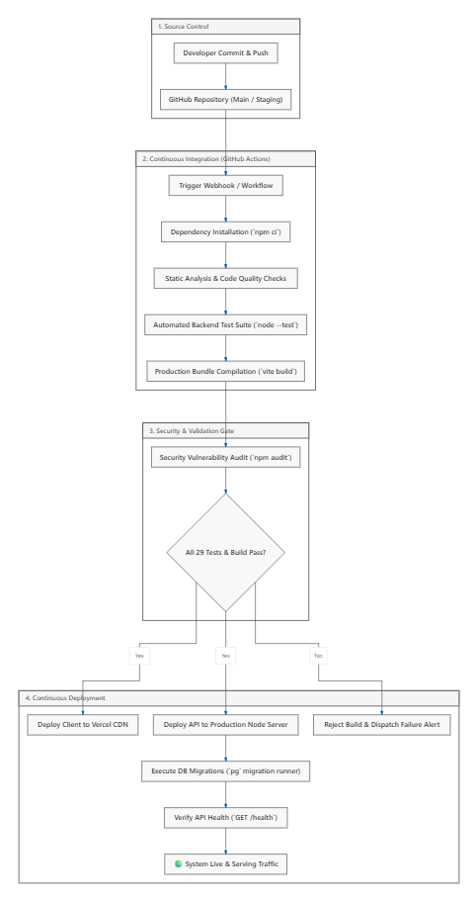

Figure 6. CI/CD Pipeline
CI/CD, which combines both Continuous Integration and Continuous Delivery/Deployment, is an automated approach to software engineering and it incorporates a series of actions, including building, testing, validating, and releasing of applications. This method is responsible for moving software from the development environment to the production platform. The CI/CD pipeline that is in action can be illustrated by the below steps. The source control is the first step of the pipeline, where the developers can write and upload their code changes to GitHub repositories (main and staging branches). The changes activate the GitHub actions workflow that is responsible for the installation of dependencies via npm ci, verification of code quality via Node.js backend, and production bundle creation via vite build.

Prior to the deployment of the software, the pipeline includes security and validation gates. The security audit is carried out via automated means and involves the usage of some kind of vulnerability audit tool from the npm repository. The audit is followed by validation which confirms that all tests and quality checks are correct. In case of negative results, the process stops, and the development team is informed about the issues that need fixing. Nevertheless, when the validation assessment is successfully completed, the next step is to move towards continuous deployment. The frontend and backend of the solution are launched on Vercel and the production server respectively. The necessary steps of PostgreSQL migrations are accomplished along the way with the help of pg migration runner.

The CI/CD methods are important parts of the software engineering process because they deal with the automation of integration, testing, and release of the software (Parmar, T. 2025). The utilization of different techniques such as version control, automated checking, security check, build management, and continuous delivery leads to almost no cases of errors caused by manual performance of the above processes.

Similarly, Mylsamy, S. and Mehrotra, T. (2025) observe that CI/CD helps the software engineering process by allowing frequent integration of code and automated testing, thereby speeding up delivery as well. In the system suggested in the paper, automatic workflow allows receiving immediate feedback on changing conditions in the repository thanks to GitHub Actions and detecting any syntax errors, testing issues, common security problems, and build errors in the process.

It can be concluded that the CI/CD pipeline that has been constructed for the system allows for automation, security testing, testing and continuous deployment as part of the DevOps process. The pipeline incorporates all the processes, including GitHub source control, GitHub Actions automation, installing dependencies, static analysis, automated backend testing, security assessment, production build, deployment, migration of the database and API health building into a single pipeline and hence validates changes more efficiently and effectively. This automated workflow leads to less manual interaction, better reliability of software and being in line with continuous improvement throughout the system development process.

3.3. Testing Strategy
This study intends to demonstrate that the AI-Assisted Performance Review and Skill Development System fulfill both its functional and non-functional needs as a system following the principles of software testing according to Pressman & Maxim (2020) to guarantee that the system functions properly, securely, and successfully in its role to enable employee performance review, skill development, learning management, and AI-related analytics in the hotel and restaurant sector.

The testing will be performed step-by-step during the life cycle of system development to find out potential errors quickly, confirm that the system works well as integrated, and verify if the actual written function meets the current needs of Human Resources (HR) people, management staff, supervisors, and employees.

Unit Testing
Unit Testing is carried out to check whether each module of the system works before the system is integrated as a whole. For this reason, testing of each module is done separately according to predefined test cases and input values, thus checking whether the results are as expected. The modules that are subject to unit testing are as follows: the Performance Management Module, Competency Management Module, Learning Management Module, Training Management Module, Succession Planning Module, and Social Recognition Module. It also includes the Report Generation Module, Authentication and Role-Based Access Control, and the AI-Assisted Performance and Learning Analytics Dashboard. This testing helps in identification of coding errors of the system.

Integration Testing
Integration Testing helps fulfill the purpose of ensuring the cooperation and transmission of data between modules of the proposed system. Essentially, Integration Testing ensures that employee details, performance assessment reports, educational activities, skill acquisition records, and AI-generated information pass on correctly between the modules without any inconsistencies or mistakes in communication. It also checks if the database, RESTful APIs, authentication systems, reporting services, and AI model providing performance reports, educational information, and development advice were integrated well.
System Testing
System Testing is to evaluate the complete integrated system to check the compliance of all the functional and non-functional requirements. In the system testing we have four key testing types:

Testing Type | Description
Functional Testing | Functional testing is conducted in order to determine whether all of the key features of the new system work as stated in the specifications. This checks the performance reviews of employees, tracking of competence development and learning activities, performance evaluation and learning analytics supported by AI, report generation, visualization on the dashboard, user authentication, and access restriction based on roles.
Performance Testing | Performance testing is designed to measure how quickly and efficiently the system performs when working under normal and heavy load conditions. This means that particular emphasis is placed on the speed of the loading of the dashboard, report generation, database transactions, and the time of processing and getting AI-based performance and learning summaries.
Security and Data Privacy Testing | Security testing focuses on making sure that all information about employees and their performance is kept safe from theft due to the proper authentication, role-based access, encrypted data transfer and storage.
Usability Testing | The evaluation of usability, accessibility, and user experience of the system is done. It is evaluated whether the system is easy to use and the navigation is not complicated by HR Administrators, Managers, Supervisors, and Employees. The AI-Assisted Performance and Learning Analytics Dashboard should represent information in a straightforward manner that can help in day-to-day work of the HR Department.
Table 6. Testing Strategy

User Acceptance Testing (UAT)
User Acceptance Testing (UAT) will take place with the users of the proposed system which comprise the Human Resource employees, managers, supervisors, and employees from partner organizations in the hotel and restaurant industry. The participants will be assigned realistic jobs to perform, such as conducting employee evaluation, documenting their learning and job development events, examining the AI-enabled performance and learning analytics, as well as creating reports. The feedback collected during UAT will help to determine whether the proposed system meets the needs of the users, integrates with Human Resource processes, and meets the objectives of the research.

3.4 Innovation Framework
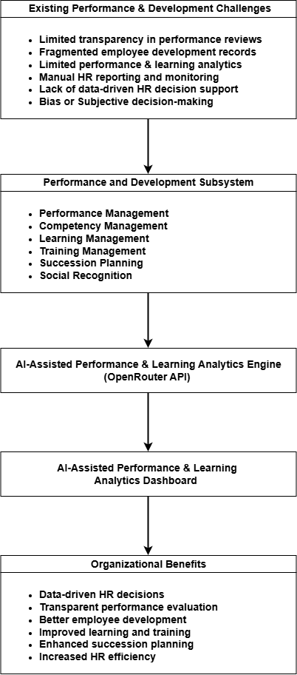
The Innovation Framework shows the process of how the proposed Performance and Development Subsystem is able to convert its existing performance management and development difficulties to a data-driven Human Resource method. It reflects the relation of the described problems of the organization, the modules of the system’s core functionality, the AI-Assisted Performance and Learning Analytics Engine, and the main advantages of the organization which will be obtained with the help of that method. The framework presents the proof of the idea of the possible application of contemporary software solutions and AI-based analytic technologies for successful implementation of the system, which is aimed at achieving improvements in performance management, people development, training, succession planning, social recognition, and making HR decisions in the hotel and restaurant industry.

Figure 6. Innovation Framework

REFERENCES
- Abdelwahed, N. A. A., & Doghan, M. A. A. (2023). Developing employee productivity and performance through work engagement and organizational factors in an educational society. Societies, 13(3), 65. https://www.mdpi.com/2075-4698/13/3/65
- Arugula, B. (2021). Implementing DevOps and CI/CD Pipelines in Large-Scale Enterprises. International Journal of Emerging Research in Engineering and Technology, 2(4), 39-47.
https://scholar.google.com/scholar?hl=tl&as_sdt=0%2C5&q=CI/CD+%26+DevOps+Pipelines&btnG=#d=gs_qabs&t=1784479835936&u=%23p%3DvNI7AFYbYw0J
- Asgeirsson, M. H., Gudlaugsson, T., & Jóhannesson, G. T. (2024). The relationships between service quality, reputation, and performance in hospitality. Tourism and Hospitality, 5(3), 736–752. https://www.mdpi.com/2673-5768/5/3/43
- Balzano, M. (2024). At the cybersecurity frontier: Key strategies and persistent challenges for business leaders. Strategic Change. https://onlinelibrary.wiley.com/doi/full/10.1002/jsc.2622
- BambooHR. (2026). Human resource management system (HRMS). BambooHR Resources Glossary. https://www.bamboohr.com/resources/hr-glossary/human-resources-information-system-hrms
- Barman, U. & Joshi, K. (2025). Polyglot Persistence - Usage and Challenges. https://urfpublishers.com/article/view/polyglot-persistence-usage-and-challenges
- Bhanu, M. V. V., & Sivakalyankumar, E. (2022). Employee development through competency mapping: A conceptual study. IOSR Journal of Business and Management, 24(2), 42-53. https://scholar.google.com/scholar?hl=tl&as_sdt=0,5&as_ylo=2022&q=employee+competency+development#d=gs_qabs&t=1783885317755&u=%23p%3DFH9oUVObiFgJ
- Business News Daily. (2026). BambooHR software review 2026. Business News Daily Technology Review. https://www.businessnewsdaily.com/16117-bamboohr.html
- Dadaboyev, S. et. al (2025). AI in HR analytics: A synthesis of current research and future directions. Proceedings of the AAAI Symposium Series, 6(1), 60–60. https://ojs.aaai.org/index.php/AAAI-SS/article/view/36026
- Dalal, R. S., Howard, D. J., Bennett, R. J., Posey, C., Zaccaro, S. J., & Brummel, B. J. (2022). Organizational science and cybersecurity: Abundant opportunities for research at the interface. Journal of Business and Psychology, 37(1), 1–29. https://link.springer.com/article/10.1007/s10869-021-09732-9
- Eboigbe, E. O., Farayola, O. A., Olatoye, F. O., Nnabugwu, O. C., & Daraojimba, C. (2023). Business intelligence transformation through AI and data analytics. Engineering Science & Technology Journal, 4(5), 285–307. https://fepbl.com/index.php/estj/article/view/616
- Elkhwesky Z, Elkhwesky EFY (2023), "A systematic and critical review of Internet of Things in contemporary hospitality: a roadmap and avenues for future research". International Journal of Contemporary Hospitality Management, Vol. 35 No. 2 pp. 533–562, doi: https://doi.org/10.1108/IJCHM-01-2022-0090
- Fitzgerald, N. (2025, May 6). Optimizing learning management system implementation for HR analytics. HR Analytics Trends. https://www.hr-analytics-trends.com/blog/optimizing-learning-management-system-implementation-for-hr-analytics
- Gélinas, D., Sadreddini, A., & Vahidov, R. (2022). Artificial intelligence in human resources management: A review and research agenda. Pacific Asia Journal of the Association for Information Systems, 14(6), 1–42. https://doi.org/10.17705/1pais.14601
- Gezici, B., & Tarhan, A. K. (2022). Systematic literature review on software quality for AI-based software. Empirical Software Engineering, 27(3), 66. https://scholar.google.com/scholar?as_ylo=2022&q=software+quality&hl=tl&as_sdt=0,5#d=gs_qabs&t=1784477189526&u=%23p%3DxhkTIVyoC5EJ
- Hussain, A. R. A. G., Vasudevan, H., Zhang, Q., & Cheok, M. Y. (2025). Evaluating the impact of Human Resource Information Systems on organizational performance in the Maldivian tourism and hospitality sector. Human Resources Management and Services, 7(2), 4617-4617. https://scholar.google.com/scholar?hl=tl&as_sdt=0%2C5&as_ylo=2022&q=hris+in+hospitality+industry+in+philippines+performance&oq=hris+in+hospitality+industry+in+philippines+perfor#d=gs_qabs&t=1783882044006&u=%23p%3DXaKhaR_N-foJ
- Kaul, D. (2023). Ai-driven real-time inventory management in hotel reservation systems: Predictive analytics, dynamic pricing, and integration for operational efficiency. Emerging Trends in Machine Intelligence and Big Data, 15(10), 66-80. https://scholar.google.com/scholar?as_ylo=2022&q=Microservice+Architecture+hotel+and+restaurant&hl=tl&as_sdt=0,5#d=gs_qabs&t=1784394065412&u=%23p%3DykwUOYYinhAJ
- Kessavane, I. (2025). HR Analytics and Predictive Modeling. https://www.ijfmr.com/papers/2025/2/41898.pdf
- Khattak, K. N., Qayyum, F., Naqvi, S. S. A., Mehmood, A., & Kim, J. (2023). A systematic framework for addressing critical challenges in adopting DevOps culture in software development: A PLS-SEM perspective. Ieee Access, 11, 120137-120156.
https://scholar.google.com/scholar?hl=tl&as_sdt=0%2C5&q=devops+culture+software+development&oq=DevOps+Culture#d=gs_qabs&t=1784478540085&u=%23p%3Dcv7jkSRowTIJ
- Kim, S. et al. (2024). Strategic human resource management in the era of algorithmic technologies: Key insights and future research agenda. Human Resource Management. https://onlinelibrary.wiley.com/doi/10.1002/hrm.22268
- Kong, X., Wu, Y., Wang, H., & Xia, F. (2022). Edge computing for Internet of Everything: Opportunities, challenges, and future directions. IEEE Internet of Things Journal, 9(14), 11101–11121.
https://ieeexplore.ieee.org/abstract/document/9863881
- Kotsakov, V. (2024). Digitalization and artificial intelligence in the hotel and restaurant sector, and the attitudes of the staff. In Икономически растеж, бизнес перспективи, пазарно позициониране в условията на криза (pp. 676-692). Международно висше бизнес училище. https://scholar.google.com/scholar?hl=tl&as_sdt=0%2C5&as_ylo=2022&q=digital+HR+system+in+Hotel+and+Restaurant&btnG=#d=gs_qabs&t=1783880016289&u=%23p%3DXMq_W9H6vzcJ
- Kumar, G., Saha, R., Gupta, M., & Kim, T. H. (2024). BRON: A blockchained framework for privacy information retrieval in human resource management. Heliyon, 10(13), e33393. https://www.sciencedirect.com/science/article/pii/S2405844024094246
- Manoharan, P. (2024). A review on cybersecurity in HR systems: Protecting employee data in the age of AI. International Journal of Advanced Research in Science, Communication and Technology. https://www.researchgate.net/publication/380885678_A_Review_on_Cybersecurity_in_HR_Systems_Protecting_Employee_Data_in_the_Age_of_AI
- Maqueira Marín, J. M., Moyano-Fuentes, J., Martínez-Jurado, P. J., & Sacristán-Díaz, M. (2022). Cloud computing and human resource management: Systematic literature review and future research agenda. The International Journal of Human Resource Management, 33(6), 1213–1241. https://doi.org/10.1080/09585192.2021.1879204
- Marneros, S., Papageorgiou, G., & Efstathiades, A. (2022, May). Developing hospitality management core competencies framework. In Proceedings of the 5th International Conference on Tourism Research (Vol. 15, No. 1). https://scholar.google.com/scholar?hl=tl&as_sdt=0%2C5&as_ylo=2022&q=competency+management+Hotel+and+Restaurant&btnG=#d=gs_qabs&t=1783883461173&u=%23p%3DplPsYUBEQkQJ
- Mosquera, D. M. et al. (2025). Polyglot Persistence in Heterogeneous NoSQL Database Systems with Python. https://link.springer.com/chapter/10.1007/978-3-031-98287-3_28
- Mylsamy, S., & Mehrotra, T. Continuous Integration and Continuous Delivery (CI/CD) Pipelines. https://scholar.google.com/scholar?start=20&q=CI/CD+Pipeline+Design&hl=tl&as_sdt=0,5&as_ylo=2022#d=gs_qabs&t=1785109895958&u=%23p%3DA2NPcWwNKmAJ
- Ozkaya, I. (2021). Can We Really Achieve Software Quality?. IEEE Softw., 38, 3-6. https://doi.org/10.1109/ms.2021.3060552
- Parker, M. C. A., & Jubac, A. C., Jr. (2026). The mediating role of AI adoption in talent management in the relationship between TOE factors and perceived talent management effectiveness in Metro Manila organizations. Journal of Business and Management Studies, 8(8), 105–123. https://doi.org/10.32996/jbms.2026.8.8.11
- Parmar, T. (2025). Implementing CI/CD in Data Engineering: Streamlining Data Pipelines for Reliable and Scalable Solutions. Available at SSRN 5190570. https://scholar.google.com/scholar?as_ylo=2022&q=CI/CD+Pipeline+Design&hl=tl&as_sdt=0,5#d=gs_qabs&t=1785109288217&u=%23p%3D7weKvWfSOK4J
- Paulino, E. P. (2023). Amplifying organizational performance from business intelligence: Business analytics implementation in the retail industry. Journal of Information Systems Engineering and Management, 8(3), 22488. https://jemi.edu.pl/vol-18-issue-2-2022/amplifying-organizational-performance-from-business-intelligence-business-analytics-implementation-in-the-retail-industry
- Poulose, S., Bhattacharjee, B., & Chakravorty, A. (2025). Determinants and drivers of change for digital transformation and digitalization in human resource management: a systematic literature review and conceptual framework building. Management Review Quarterly, 75(3), 1911-1936. https://scholar.google.com/scholar?as_ylo=2022&q=Human+Resource+Information+System&hl=tl&as_sdt=0,5#d=gs_qabs&t=1783878623381&u=%23p%3D2WhST9YcV8QJ
- Pressman, R. S., & Maxim, B. R. (2020). Software engineering: A practitioner’s approach (9th ed.). McGraw-Hill Education.
https://www.mheducation.com/highered/product/Software-Engineering-A-Practitioners-Approach-Pressman?need_sec_link=1&sec_link_scene=im&viewOption=student
- Radhika, B. (2018). PERFORMANCE APPRAISAL SYSTEMS: ENHANCING FAIRNESS AND TRANSPARENCY. https://ijrar.org/papers/IJRAR19D5378.pdf
- Rahman, M. M., Faruk, O. M., & Jyoti, S. N. (2025). Data privacy in business intelligence systems: Ensuring compliance in HRIS and enterprise platforms. International Journal of Scientific Interdisciplinary Research. https://ijsir.org/index.php/IJSIR/article/view/21
- Raja, M., et al. (2024). Does human resource information system influence performance management?. https://www.tandfonline.com/doi/full/10.1080/23311975.2024.2438862#abstract
- Rebman, C. M., Jr., Booker, Q. E., Wimmer, H., Levkoff, S., McMurtrey, M., & Powell, L. M. (2023). An industry survey of analytics spreadsheet tools adoption: Microsoft Excel vs. Google Sheets. Information Systems Education Journal, 21(5), 29–42. https://files.eric.ed.gov/fulltext/EJ1409034.pdf
- Romano, K. A. R., Masilungan, R. S., Cacho, L., & Melendres, U. M. (2020). eCarte: An interactive restaurant menu with feedback collection. Mindanao Journal of Science and Technology, 18(1). https://scholar.google.com/scholar?hl=tl&as_sdt=0%2C5&q=interactive+dashboard+hotel+and+restaurant+in+philippines&oq=interactive+dashboard+hotel+and+restaurant+in+Philippin#d=gs_qabs&t=1784192861549&u=%23p%3D_i6yXhrnUOIJ
- Rustam, A., Astuti, I. Y., & Safitri, U. R. (2024). Strategies for improving employee competencies in the digitalization era through training and human resource development. The Journal of Academic Science, 1(7), 849-857. https://scholar.google.com/scholar?hl=tl&as_sdt=0,5&as_ylo=2022&q=employee+competency+development#d=gs_qabs&t=1783885866413&u=%23p%3DNFC23mcJHm4J
- Sabale, A. A., & Subashini, R. (2024). Enhancing HR efficiency through the integration of artificial intelligence and Internet of Things: A study on AI implementation in human resource management. EAI Endorsed Transactions on Scalable Information Systems, 11(2), Article 4208.
https://www.proquest.com/docview/3275667432?pq-origsite=gscholar&fromopenview=true&sourcetype=Scholarly%20Journals
- Sakai, K. (2026). Key performance indicators in workplace health promotion. Journal of Occupational and Environmental Medicine, 68(1), 23–31. https://pubmed.ncbi.nlm.nih.gov/40968566/
- Schiliro, F. (2023). Towards a contemporary definition of cybersecurity. arXiv. https://www.researchgate.net/publication/368304689_Towards_a_Contemporary_Definition_of_Cybersecurity
- Tang, F. et al. (2025). Explainable person–job recommendations: Challenges, approaches, and comparative analysis. Frontiers in Artificial Intelligence, 8. https://www.frontiersin.org/journals/artificial-intelligence/articles/10.3389/frai.2025.1660548/full
- Thatikonda, V. K. (2023). Beyond the buzz: A journey through CI/CD principles and best practices. European Journal of Theoretical and Applied Sciences, 1(5), 334-340.
https://scholar.google.com/scholar?hl=tl&as_sdt=0%2C5&q=CI%2FCD+practices&btnG=#d=gs_qabs&t=1784479265215&u=%23p%3DnCwU5rkx8PEJ
- Thrivea. (2025). BambooHR review 2025: Features, pros and cons, and alternatives. Thrivea Insights. https://thrivea.com/blog/bamboohr-review
- Tuffaha, M. (2023). The impact of artificial intelligence bias on human resource management functions: Systematic literature review and future research directions. European Journal of Business and Innovation Research, 11(4), 1–19. https://www.researchgate.net/publication/372408667_The_Impact_of_Artificial_Intelligence_Bias_on_Human_Resource_Management_Functions_Systematic_Literature_Review_and_Future_Research_Directions
- Vuong, T. D. N., & Nguyen, L. T. (2022). The key strategies for measuring employee performance in companies: A systematic review. Sustainability, 14(21), 14017. https://www.mdpi.com/2071-1050/14/21/14017
- Zhang, Y., Chen, L., & Wang, H. (2020). Edge computing and IoT integration for real-time workforce performance monitoring. IEEE Access, 8, 56789–56802.
https://ieeexplore.ieee.org/abstract/document/9052677?need_sec_link=1&sec_link_scene=im
- Żukowska, J. & Szymczak, A. (2025). Using an agile approach in human resource management – a theoretical approach. https://www.researchgate.net/profile/Joanna-Zukowska-3/publication/395955009_Using_an_agile_approach_in_human_resource_management_-_a_theoretical_approach/links/68da9ae502d6215259b6dac6/Using-an-agile-approach-in-human-resource-management-a-theoretical-approach.pdf

APPENDICES

APPENDIX A. DETAILED TECHNICAL DOCUMENTATION

A.1 SYSTEM ARCHITECTURE
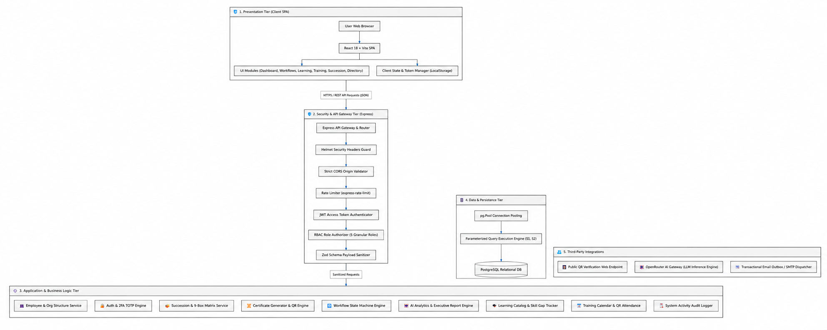
The architecture incorporates a layered style of architecture whereby it separates presentation, security, business processes, data, as well as external integrations. The React 18 and Vite based frontend is responsible for the user interface, where its functionalities to access and communicate with the API Gateway are powered by the usage of Express framework to accomplish security requirements through the application of JWT, RBAC, validation, security control and rate limiting. The Application and Business Logic Layer handles functions of the HR part with the usage of such components as employee management, workflows, performance, succession, certificates and education processes.

A.2 Information Systems Integration

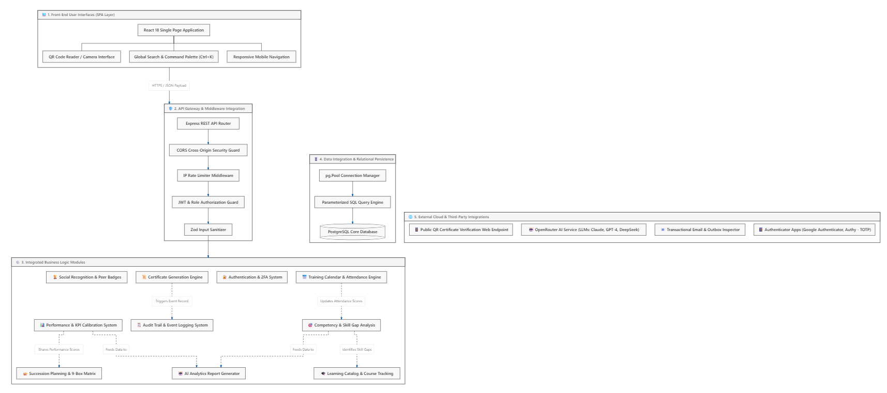
The Information Systems Integration Diagram indicates how different parts of the PerDevSys function together to create a whole HR platform. This can be seen via the React 18 user interface and features of the platform, such as QR code scanning, worldwide search, and mobile navigation of the platform, while the requests are accomplished through the Express API Gateway with middleware that is responsible for executing requests securely using such approaches as CORS protection, rate limiting, JWT/RBAC authorization, and input validation. The Integrated Business Logic Layer creates links between the main HR processes that comprise performance and KPI calibration, competence and skill gap analysis, learning and learning tracking, training and attendance, workforce succession processes, social recognition, as well as functions of generating certificates and 2FA.

A.3 Application Design and Development
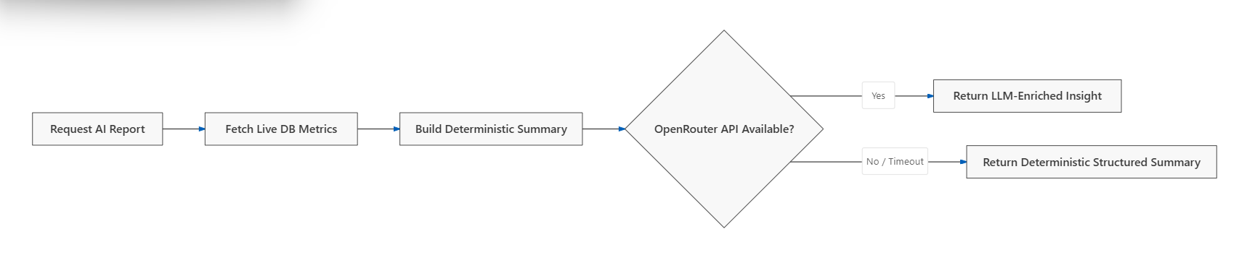
The system employs a number of software design patterns and architectural principles to guarantee that it will be both structured and maintainable, as well as secure and reliable. The main element responsible for carrying out the processes of the system uses the Deterministic State Machine Model because it works based on the principle of completion of various steps that are known from the very beginning, which means that in case of an evaluation being done in accordance with the KPI principles, the process will include the following phases: from the configuration of KPIs to self-assessment done by the employee, evaluation completed by the supervisor and HR calibration. The transitions of the workflow are regulated through the systems of user authentication and authorization based on the particular role of the user. Furthermore, the system allows for the workflow being brought back to the previous phase if needed and registering this process in the audit trail of the workflow.

The AI function follows the principle of Graceful Degradation or Fail-Safe Fallback Pattern for keeping the system operational. When the LLM outside the system via OpenRouter is available, the system passes the properly computed workforce metrics for using them for making the AI-based report. However, if the external service is not available, has a bug, or exceeds the needed time for responding, then the system generates the fallback report based on deterministic rules and computed values from the database. This method gives assurance that users have access to the required information from the system even if the AI services are unavailable.

The front-end also utilizes Component-Based Architecture which implies that reusable components are created for the performance of standard functionalities of the system. The components include global search and command palette, AI insight panels specific for each module, two-factor authentication interface, notification components, and email monitoring tools. This way, it becomes possible to achieve high code reusability, consistency, maintainability, and unified user interface of the whole system.

Front-End Architecture and Design
The front end development is done employing the use of React-based SPA configuration aided by Vite tool. React Router makes such navigation possible, permitting role-protected pages routing. The applicable interface is styled according to the applicable styling system, including dark mode and light mode implementation, usage of responsive layouts and nice transitions to provide the users’ absolute satisfactory experience.

The hierarchical structure of the application is organized in such a way as the main application component takes care of routing and session information. It is worth noting that some components are being shared among web pages, such as the header, sidebar, global search, notifications, security settings, etc. The center of the interface can include several modules, like performance management, competency management, learning management, training management, succession planning, social recognition, employee records, certificate management, AI analytics, and audit logs.

Back-End Architecture and Development
The technology used in the back-end is Node.js, Express.js and follows the principles of RESTful API. PostgreSQL is the database that has its ORM tool page along with the connection pool for smooth communication with its database. Zod, JSON Web Tokens (JWT), bcrypt, and TOTP authentication are examples of tools used for input validation, authentication, password encryption, and two-factor authentication. Helmet is used for security purposes and rate limiting is applied to avoid overloading or unwanted requests on the HTTP service.

The architecture of the back-end system is layered architecture. The requests from the clients should first go through the gateway and middleware layer where the incoming requests are validated, CORS optimized and throttled. The next layer is the routing layer where the users are sent to the required API endpoints. The next layer is validation and authorization where the input and authentication of the user is checked. The next layer is the service or business logic layer where all the service and business matters are taken care of, and finally the database layer which interacts with PostgreSQL through connection pooling and parameterized SQL queries.

Core Algorithms and Calculation Methods
The system relies on established calculation techniques in terms of performance evaluation and succession planning. The calculation system scores performance by putting together the results of KPIs, employee self-evaluation, and supervisor’s evaluation by applying weights to all the parties involved. The calculation comes from 50% of the supervisor’s assessment, 30% of the KPI assessment, and 20% of employee self-assessment. But, when HR performs calibration in the evaluation of performance the final score may change the calculated score. This makes it possible for the organization to use human evaluation and various contextual factors before getting the final score.

The system calculates the employee’s readiness score for succession planning by measuring the performance score, competency score, and learning progress score of the employee. The result shows how much performance score contributes to the employee’s readiness ranking – 50%, competency ranking – 30%, and learning progress ranking – 20%. Depending on the score, the employee may fall under one of the readiness categories – Ready Now, Ready in 1-2 Years, or Development Needed. These ratings are useful for HR and managers to find the candidates for future managers among their employees.

Development Practices and Quality Control
The software development and quality assurance techniques employed follow systematic processes. Version control is done using Git while the following commit types are observed: feat (new feature), fix (bug fix), refactor (refactoring). The system has automated tests covering all important business scenarios (medium of work, movement of role access, scoring, and fallback of AI). Furthermore, the production build is checked against the project build process to eliminate possible issues of compilation or configuration prior to deployment.
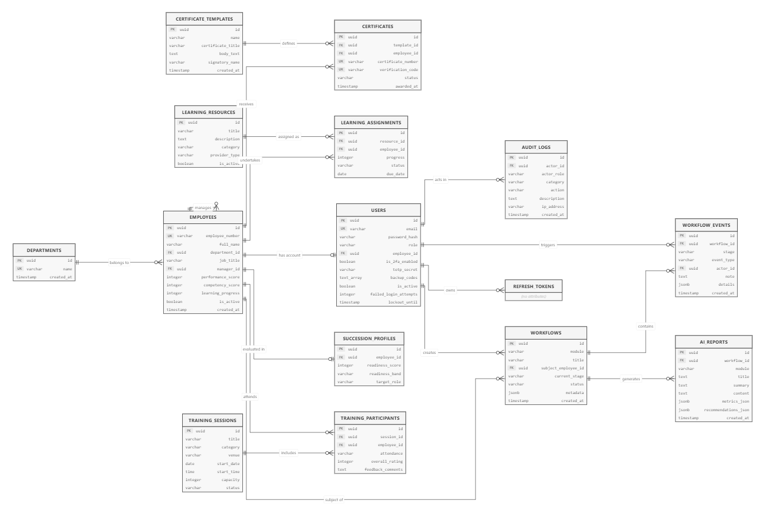
A.4 Database Schema and Data Management
The illustration depicts the ERD for the Performance and Development System database. It shows how the principal entities in this system interact with each other. The entities are the employees, users, departments, workflows, learning, training, succession, certificates, AI report, and audit logs. The diagram emphasizes the organization and connection of data to assist with the personnel development operations of the system.

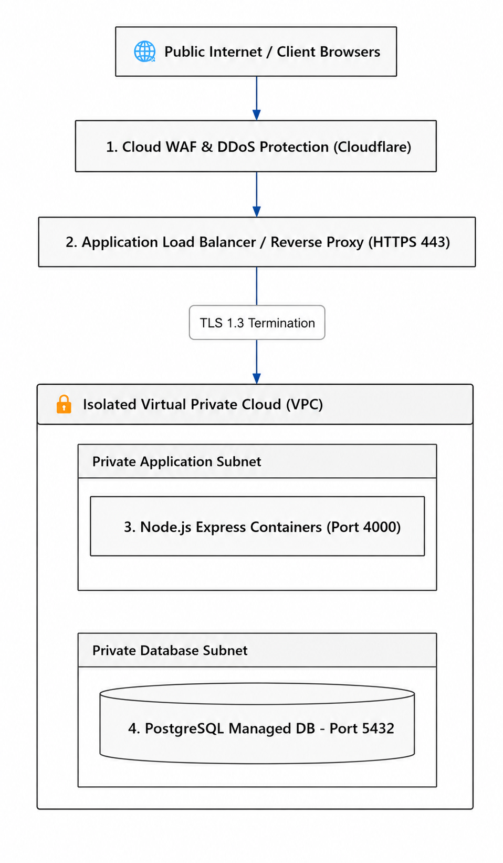
A.5 Network Configuration

The depicted diagram shows the system's architecture in terms of its deployment and security. The procedure reveals how client requests travel through Cloudflare WAF, DDoS Protector as well as Load Balancer/Reverse Proxy before arriving at Node.js Express application implemented on the dedicated VPC. The Node.js Express application communicates in a secure way with PostgreSQL managed DB sitting in another private database subnet.

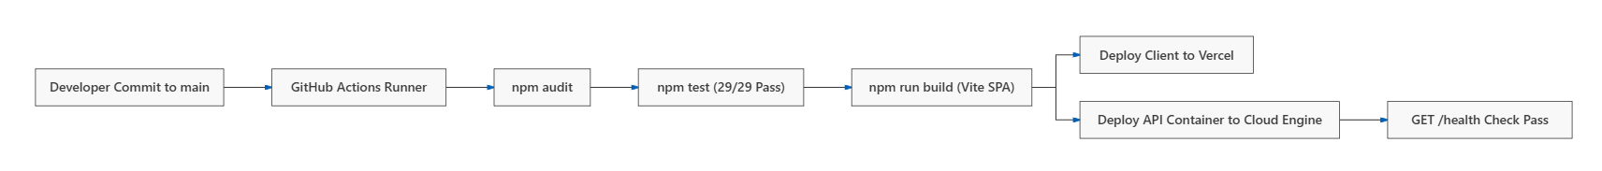
A.6 Deployment and Infrastructure
The provided diagram depicts the automated deployment process of the system. The cycle starts when the developer makes a commit in the primary branch and the GitHub Actions gets triggered to conduct dependency checks and execute automated tests. After the testing is over successfully, the system is created as a Vite Single Page Application (SPA). Once the frontend client has been deployed onto Vercel, the backend API container gets deployed on Cloud Engine. Lastly, the GET /health check is performed for ensuring the functionality of the deployed API.

A.7 Security Measures
The application utilizes various layers of security to secure user accounts, sessions, application data, and system resources. Passwords are protected via bcryptjs hash functions, powerful password policy implementation, rate limiting, and lockout prevention from unauthorized access. The app features Two-Factor Authentication (2FA) and has various options for enrollment and recovery codes. Sessions are secured via the use of short-lived JWT access tokens and use of rotating refresh tokens and automatic logout after 10 minutes of inactivity. Protection from SQL injection attacks is also provided via the use of parameterized SQL calls and Zod validation, while the use of Helmet middleware and hidden server fingerprints provide further security from HTTP attacks. The audit trail records all security activities while the certificates can be verified using UUID-based QR codes.

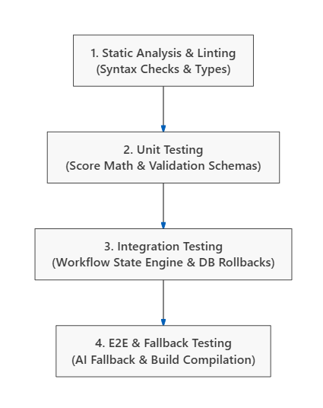
A.8 Testing and Quality Assurance

The diagram shows the different stages of quality assurance that the system goes through. The process begins with static analysis, which detects syntax errors and issues relating to types. Next comes unit testing to check for correctness of functions such as scoring calculations and validation schemes. The next stage after unit testing is integration testing, and at this point, the systems’ main components are evaluated as far as their collaboration is concerned (workflow state engine, database action and rollback performance). The last step in the testing process is end-to-end and fallback testing.

A.9 System Monitoring and Maintenance
The system uses healthcare monitoring, structured logging, and maintenance routines that aid in ensuring reliable operation and availability of the system. There is a GET /health endpoint that provides information about the state of the database connection and gives a response with the appropriate HTTP status regarding the state of the respective system. System operation is logged using structured logging in JSON format through Winston with request parameters, response status, processing time, authenticated users, and IP addresses being stored while sensitive stack tracks are hidden. Regular maintenance routines include database optimization using REINDEX and VACUUM ANALYZE algorithms, automatic deletion of expired refresh tokens and revoked sessions as well as daily backup of the systems with the data being preserved for up to 30 days.

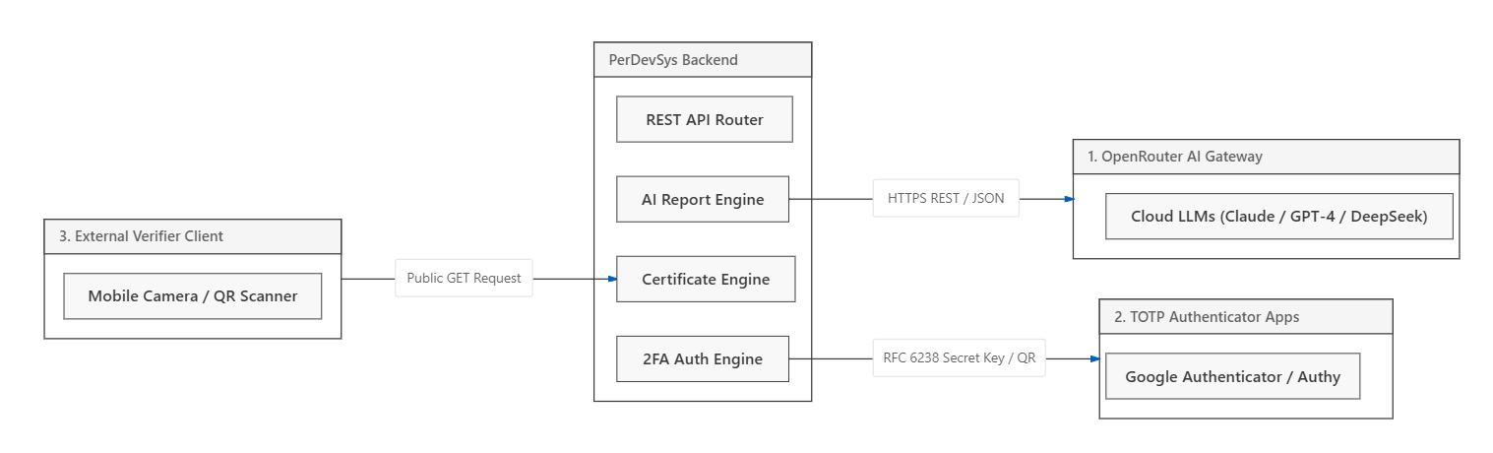
A.10 APIs and Integration Points
The system utilizes the OpenRouter AI via a secure HTTPS REST API that carries structured JSON messages that contain system instructions and other related educational data for AI-related studies and insights. The integration has built-in fallback provisions to ensure the reliability of the system and applies internal pre-defined rules should the OpenRouter service generate an error or fail to respond within the prescribed time limits. A Public QR Code Verification Integration is used in the system via an ordinary HTTP GET endpoint that allows outsiders to get information regarding a certificate with the help of a verification code. The verification endpoint has been developed as a read-only and non-authenticated service to enable easy and quick validation of certificates while ensuring that no unwanted changes are made to certificate information.

A.11 User Documentation
The system user workflow is designed with role-based navigation and intuitive UX patterns:

Role-Based Navigation Matrix
- hr (HR Administrator): Complete authority over the use of modules, employee directory, scoring adjustments, template designs for certificates, review cycles in bulk, 2FA administration, and examination of security logs.
- supervisor (Department Supervisor): Assess employees, distribute training material, check whether employees attended class, assess skills and succession matrices.
- management (Executive Management): Access overall workforce performance reporting, AI outputs, rankings in groups, and performance of departments.
- operations_manager (Ops Manager): Workflow monitoring within and between departments, training overseeing, attendance checking, and performance monitoring dashboards.
- employee (Staff Member): Option for performing self-evaluation, checking how much of the course one has completed, requesting certificates and nominations from peers, and managing 2FA settings.
A.12 Know Issues and Troubleshooting
Component / Scenario | Symptom/Error | Root Cause | Resolution / Workaround
AI Insights Generation | Insight panel displays deterministic summary without LLM enrichment. | OpenRouter API rate limit reached or network timeout. | Handled automatically: System falls back to structured deterministic summary without throwing errors or blocking workflow progress.
2FA Authentication | Invalid 2FA code error on login. | Time drift between user's phone clock and server time. | Resync authenticator app time or use one of the 8 single-use recovery backup codes generated during 2FA setup.
Session Logout | The user is redirected to login with a notification message. | Session idle for 10 consecutive minutes. | Re-authenticate. Activity listeners (click, keypress, scroll) reset the 10-minute timer automatically while active.
Database Connection | 500 Request Failed - Connection pool exhausted | Too many open concurrent database connections. | Ensure DB connection pooling limits are set (max: 20, idleTimeoutMillis: 30000) and restart the backend container.
PDF Certificate Download | The download button fails to render certificate PDF. | Browser blocking popups or canvas print rendering. | Click Copy Link to share the direct verification link or use Chrome/Edge print preview (Ctrl + P).

A.13 Version Control and Source Code Repository
The Git version control system (v2.40 +) is utilized in this project, along with GitHub, which serves as a repository platform, as a monorepo. This encompasses both the frontend client and backend server. The development is done using the Git Flow and/or trunk-based branching strategy where the main branch is the protected branch that has production-ready code and triggers the automated pipelines for deployment. There is also a staging branch for testing and integration while additional feature branches are created for features and fixes where the branches are named using feature/* and fix/* respectively and merged with the main branch after undergoing the code review process. The controlled coding standards are adhered to as well, thus ensuring an accurate commit history.

A.14 DevOps and CI/CD
The diagram illustrates the system’s DevOps and CI/CD workflow, beginning with local development where code is tested and built before being pushed to GitHub. The GitHub Actions pipeline then installs dependencies, performs code checks and automated tests, and builds the production client before deploying the frontend to Vercel and the backend to Cloud VPS/Render, followed by a health check to verify successful deployment.

A.15 Licensing and Open Source Libraries

A.16 Performance Metrics and Monitoring

APPENDIX B: PROJECT MANAGEMENT ARTIFACTS
B.1 PROJECT CHARTER / PROPOSAL

PROJECT OVERVIEW
The planned Performance and Development Subsystem (P&DSS) is a form of an information system which would be developed as a means for organizing human resource management functions whose area of application includes the areas of employee performance evaluation, competency management, learning and development, training, succession planning, and employee recognition. The system would correlate information on employees’ development and provide certain HR employees with well-organized, available, and data-based information regarding employee performance and developments.

The use of data analytics, business intelligence, cloud technologies, and Artificial Intelligence (AI) will improve the performance and presentations of employee-related information within P&DSS.

PROJECT PURPOSE
The main goal of the project is to create a centralized Performance and Development Subsystem that will help organizations in the management and monitoring of employee performance and development. The subsystem is expected to give HR specialists the necessary information about employee performance, skills, learning progress, training, and other issues related to development in a systematic way.

Moreover, the project will make use of AI as a supportive technology that will analyze all data recorded in the system and give role-based recommendations and insights.

PROJECT OBJECTIVES
The project aims to:
- Create a consolidated subsystem to coordinate employee related performance & development data.
- Include functionality for performance tracking and assessment of learning, competencies, training, career development, and recognition.
- Use data analytics and business intelligence to create various reports and dashboard concerning employees.
- Include AI analysis feature for data analysis.
- Create a chatbot that delivers responses depending on the accessed data.
- Apply Role-Based Access Control (RBAC) to protect any sensitive employee or company data.
- Help HR personnel to have neat, well-organized information about the employee’s performance and their training decisions.
- Make a cloud-based environment for centralized access of the information.

PROJECT SCOPE
The project encompasses the following key features of development and implementation:
- Performance Management – an analysis of the performance information of the employee.
- Competency Management – keeping track of employee competencies and needs.
- Learning Management – keeping track of the employee education process and training activities.
- Training Management – management of the training information of the employee.
- Succession Planning – evaluation of the succession-related and leadership readiness data.
- Social Recognition – monitoring of the recognition activities of the employee.
- Data Analytics and Business Intelligence – processing of employee-related information based on analysis and visualization tools.
- AI-Assisted Decision Support - development of insights and recommendations driven by data from the system being used.
- AI Chatbox - offering answers and assistance according to user rights and roles.
- Roles Access Control - access to information and functions in the system depending on user roles.
- Cloud Data Management - storing and retrieving information of the authorized employees and projects with cloud tools.

PROJECT DELIVERABLES
The project is expected to produce the following deliverables:
- Functioning performance and development subsystem (P&DSS)
- Database for the systeM
- Dashboard for performance and development
- Analytical reports and data
- AI-assisted analytic results
- AI-enabled chatbox based on various roles
- Documentation of the system
- Manual to be used by the end-users
- Quality assurance and testing documents
- Thesis or capstone manuscript

TARGET USERS
The proposed P&DSS would be used by authorized users including HR personnel, managers, and employees who are involved in employee performance and development management. The access to functions and information within the system would be determined by roles and rights of these users.

PROJECT METHODOLOGY
The Scrum methodology will be adopted in the project for software development purposes. The team shall divide the project into multiple sprint cycles, at the end of which the requirements and functionalities shall be selected and worked upon. There are Scrum events like Sprint Planning, Daily Scrum, Sprint Review, and Sprint Retrospective that lay down the process of coordination and continuous improvement of the team.

The major Scrum artifacts that will be utilized in the project include the Product Backlog, the Sprint Backlog, and the Increment that will serve the purpose of referring for managing requirements, controlling the activities of the ongoing sprints and tracking of functionalities already done.

PROJECT TEAM

POSITION | ASSIGNED MEMBER | RESPONSIBILITY
Project Manager | Celsi A. Garcia | Responsible for the project-based planning and coordination, scheduling, and the status of the project overall.
System Analyst | Eymard C. Buyser | Carries out an analysis of system requirements, processes, user needs, and produces specifications.
Lead Developer | Yuan A. Amboy | Direct the design, development, integration, and implementation of system functionality.
Quality Assurance (QA) Tester | Jannah Mae Nueva | Perform the testing of the system and ensure its functioning, reliability, and quality.
Document Analyst | Hexa B. An̈onuevo | Prepare, coordinate and maintain both the project documentation and technical documentation.

PROJECT CONSTRAINTS AND LIMITATIONS
There are certain technological and operational restrictions of this project that can affect how the system is applied or utilized after its introduction. The AI function relies on the availability of the external AI service, as well as the internet service. AI is capable of drawing conclusions only out of the data which are available to it and reliable insights can be generated only when enough information related to the employee or company activities is provided to AI. Moreover, the AI has mainly a decision-support function and it is not able to act on its own and make administrative decisions.

The AI chat box is also not free from limitations based on the role and access level assigned to the user. The AI chat box cannot provide information that exceeds the user's privileges. Other than that, the AI function primarily operates as a provider of information that is structured and related to the user’s job responsibilities, without any possibility of conversation.

B.2 SPRINT BACKLOGS AND BURNDOWN CHARTS

B.3 MEETING MINUTES

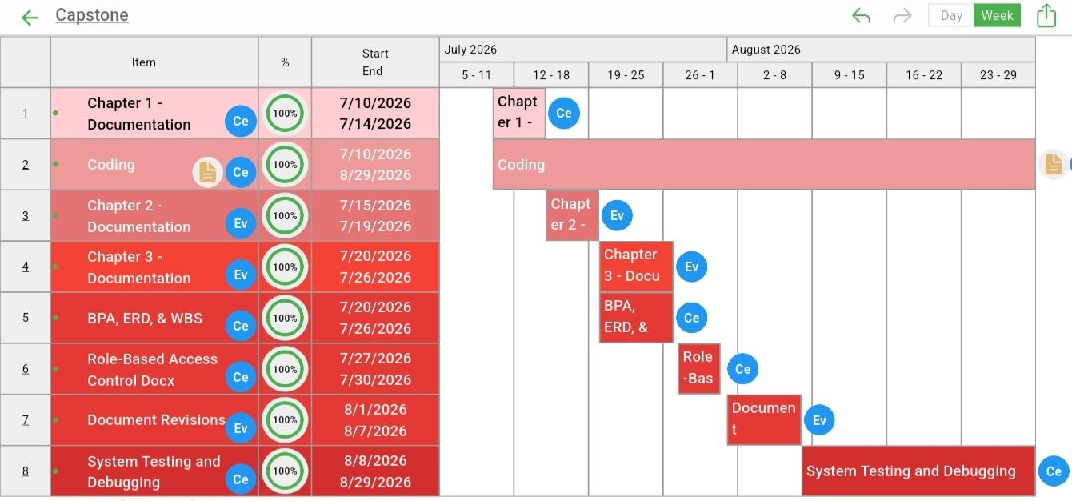
B.4 GANTT CHART / PROJECT TIMELINE

The Gantt Chart illustrates the schedule for the development of the project and specifies the time allocated for the completion of significant work in the project. It includes the completion of Chapter 1 documentation, coding, Chapters 2 and 3 documentation, development of BPA/ERD/WBS, Role-Based Access Control documentation, revisions of different documents, and testing and debugging the system. It demonstrates the time indicated for completing important tasks in the project from July to August of 2026.

APPENDIX J: RESEARCHER’S CURRICULUM VITAE
